

**SCHOOL OF INFOCOMM TECHNOLOGY**

**Cloud Architecture and Technologies (CAT)**

**Assignment - April 2023 Semester**

**35% of CAT Module – (Team: 70%, Individual 30%)**

**3 July – 9 Aug 2023 (Weeks 12 - 17)**

**Deadline for submission:**

**SOFTCOPY:** Submit in Brightspace by 09 Aug 2023, 23:59

|  |  |  |  |
| --- | --- | --- | --- |
| **Tutorial Group:** | P07 | **Team Number:** | **C** |
| **Members** | **Student No.** | **Student Name** | **Grade** |
|  | **Leong Kai En, Matthew** |  |
|  | **Ong Sze Hwee Alec** |  |
|  | **Lee Teck Wang** |  |
|  | **Xiu Han Nathan Quek** |  |
|  | **Lim Wee Liang Kelven** |  |

|  |
| --- |
| **Plagiarism Warning:**  If a student is found to have submitted work not done by him/her, he/she will not be awarded any marks for this assignment. Disciplinary action may also be taken. Similar action will be taken for the student who allows other student(s) to copy his/her work. |

**Reminder**

* **Penalty for late submission:** 10% will be deducted for each day (including Sunday and Public holidays).
* Only 1 report submission for each group is required.

**1.0 Network Diagram 5**

**2.0 Description of the Cloud Solution 6**

2.1 VPC and Auto-Scaler 6

2.1.1 EC2 Configuration 6

2.2 Load Balancer 11

2.3 CloudWatch and SNS 12

2.4 DynamoDB 14

2.5 HTML Forms Page 14

2.6 DynamoDB and S3 Notification 19

**3.0 Problems Encountered & Resolutions 20**

3.1 VPC and Auto-Scaler 20

3.2 Load Balancer 20

3.3 CloudWatch and SNS 21

3.4 DynamoDB 21

3.5 HTML Forms Page 22

3.6 DynamoDB and S3 Notification 22

3.7 Resize images 23

**4.0 How the Requirements are Implemented 23**

4.1 VPC, and Load Balancer 23

4.2 Auto-Scaler 39

4.3 CloudWatch and SNS 40

4.3.1 Create SNS Topic 40

4.3.2 Create CloudWatch Dashboard 43

4.3.3 Create CloudWatch alarm 45

4.3.4 Activate auto-scaler based on CPU utilisation 51

4.4 DynamoDB 53

4.5 HTML Forms Page 56

4.6 DynamoDB and S3 Notification 68

4.6.1 DynamoDB 68

4.6.2 S3 bucket 71

**5.0 Code Used for Lambda Functions and HTML Page 75**

5.1 Assg2_AddCustomerDetails 75

5.2 Assg2_GetCustomerDetails 77

5.3 HTML Page 78

5.4 DynamoDB Notification 81

**6.0 Testing Methods & Results 82**

6.1 VPC and Auto-Scaler 82

6.2 Load Balancer 83

6.3 DynamoDB 83

6.4 HTML Forms Page 84

6.5 DynamoDB Notification 85

6.6 S3 Notification 85

**7.0 Explanation of Cloud Solution according to Design Principles 87**

7.1 Security 87

7.2 Reliability 87

7.3 Performance Efficiency 88

7.4 Cost Optimisation 89

**8.0 Explanation of Cloud Monitoring Plan for Web Application 90**

8.1 Objectives of Cloud Monitoring 90

8.2 Techniques and Tools 90

**9.0 Other Relevant Screenshots 92**

**10.0 References 92**

# **1.0 Network Diagram**

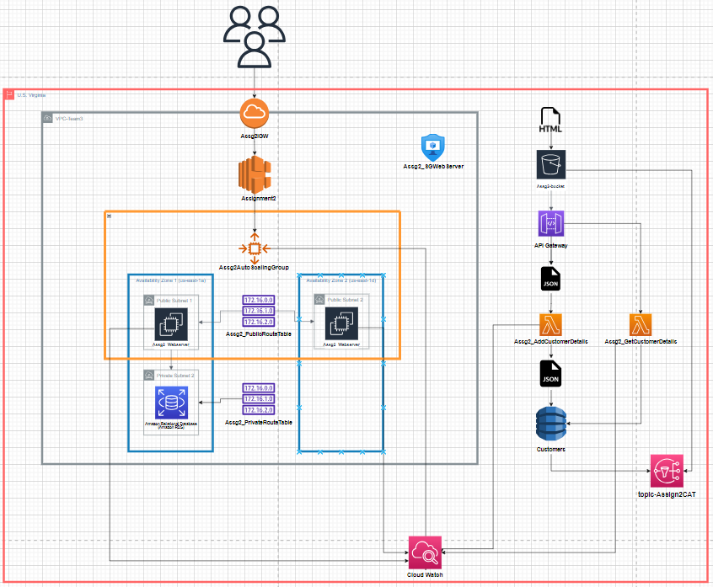

# **2.0 Description of the Cloud Solution**

## 2.1 VPC and Auto-Scaler

In the proposed cloud solution for Assignment 2, the web application would operate within a Virtual Private Cloud (VPC), consisting of 2 availability zones (AZs) spanning from us-east-1a to us-east-1b. To ensure high availability and fault tolerance, the VPC would have one public subnet for each availability zone, and additionally, two private subnets situated in AZ us-east-1a and us-east-1b.

To manage the instances powering the web application effectively, an auto-scaling group (Assg2AutoScalingGroup) would be employed. This auto-scaling group would dynamically adjust the number of instances based on demand, maintaining a minimum of 2 and a maximum of 4 instances simultaneously. The auto-scaler would use CPU utilisation as a metric to trigger scaling actions, scaling out by launching new instances when CPU utilisation reaches 60%, and scaling in by stopping instances when CPU utilisation is less than 60%. The auto-scaler would regularly perform health checks on the instances and replace any unhealthy instances, ensuring continuous availability.

For the database component, the instances in the auto-scaling group would be connected to a relation database system (RDS) using the Microsoft SQL Engine. RDS is a managed database service provided by AWS, offering data security through encryption and efficient performance management.

To enable communication between the VPC and external networks, an Internet Gateway (Assg2IGW) would be attached to the VPC. It serves as a target for the VPC route tables, enabling internet-routable traffic to and from the VPC.

### 2.1.1 EC2 Configuration

In the configuration of the cloud solution for Assignment 2, the instances of the auto-scaler are equipped with a Windows Security Group (Assg2_SGWebServer) acting as a firewall. This security group allows specific types of incoming traffic, such as HTTP or HTTPS for web application access through a web browser, a Remote Desktop Protocol (RDP) for remote access to the instances using Windows Remote Desktop Connection (RDC), MSSQL for reading information from the database, and ICMP_IPV4 for error-reporting purposes. Allowing ICMP_IPV4 enables devices to return error messages to the source IP address in case of network problems, facilitating easier debugging.

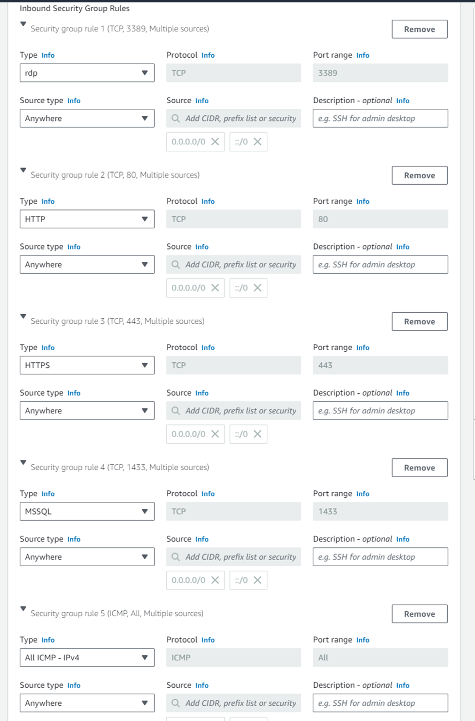

The instances are based on the Windows operating system and use the t2.micro instance type. The Windows operating system was chosen as it required both the AWS account of created instance and the public key to decrypt the private key and access the EC2 instance. This adds an additional layer of protection compared to Linux and Ubuntu instances, which enables access with just the public key.

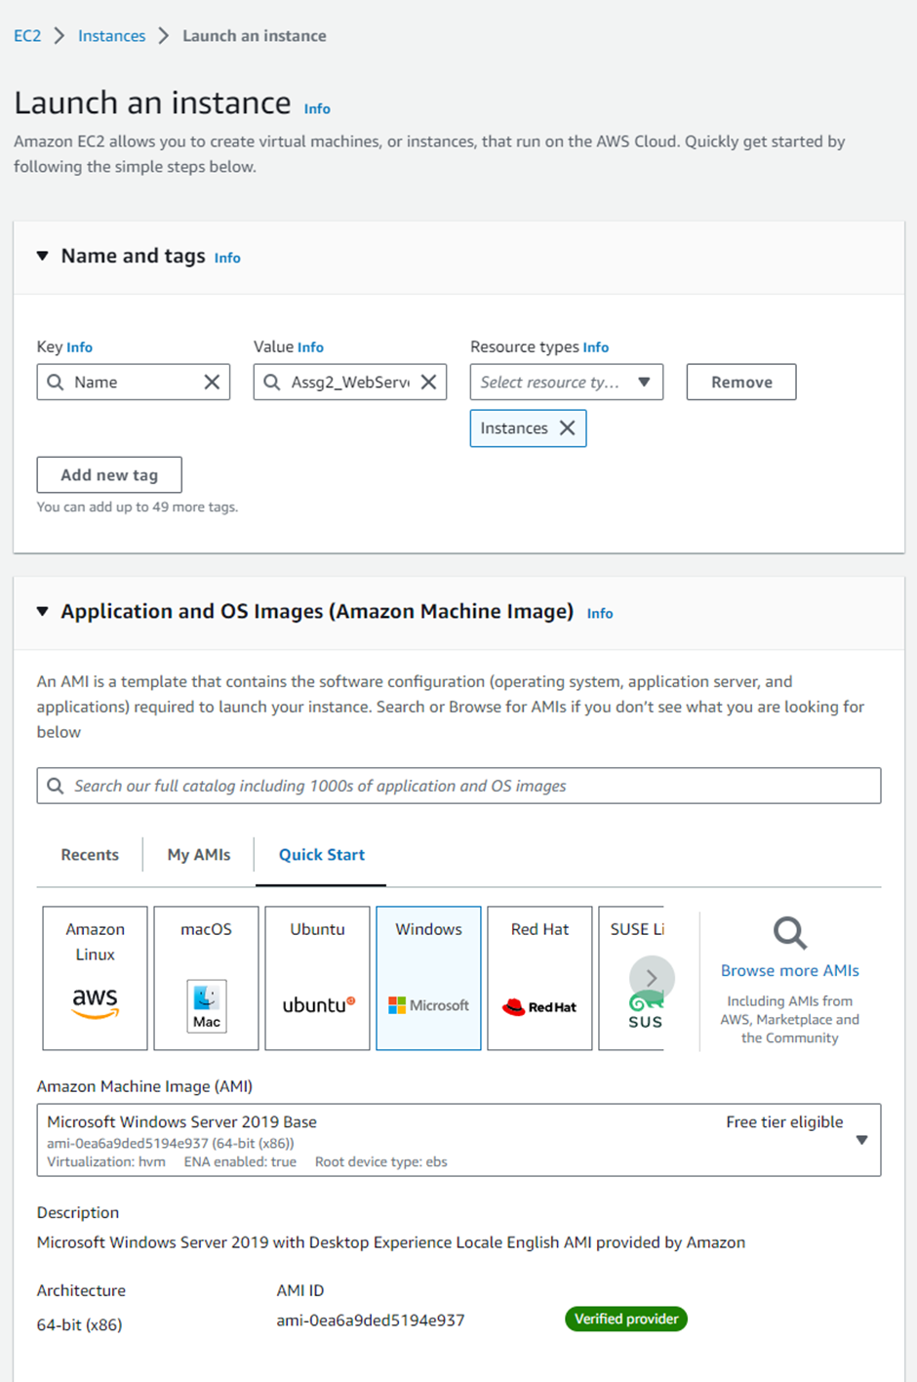

The t2.micro instance type was selected for cost optimisation since it offers a suitable balance of computation, storage, and memory services for general-purpose web applications. It uses MyEc2 Keypair and Assg2_Public_Subnet_1.

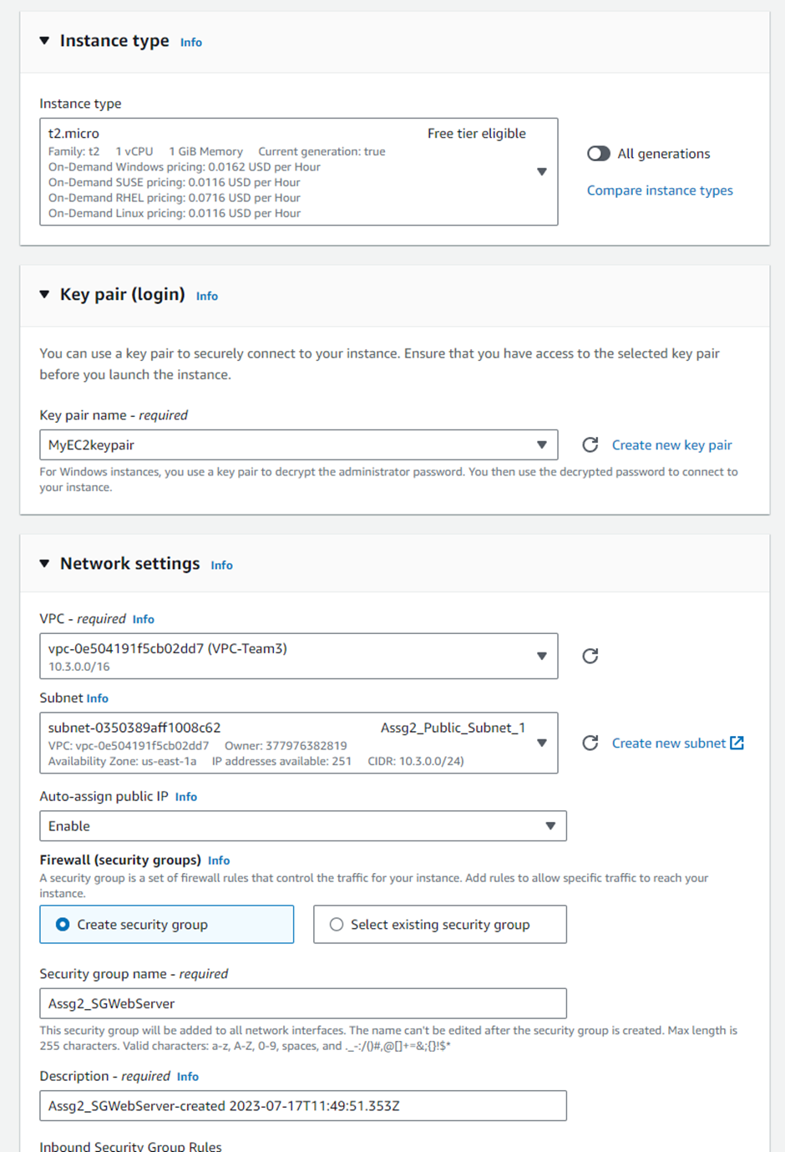

The RDS utilises an instance class of t3.small, providing 2 VCPUs and 2GB of RAM. It also uses General Purpose SSD as its storage type which balances magnetic storage (slow) and Provisioned IOPS storage (optimised throughput but expensive). The chosen configuration meets the requirements of the web application without incurring unnecessary costs.

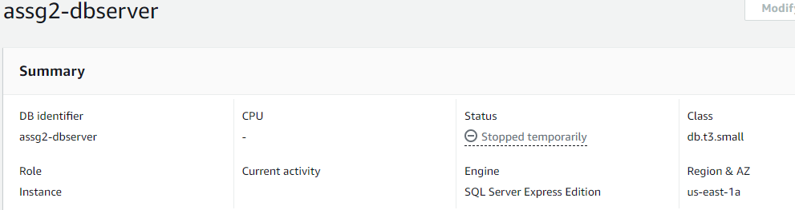

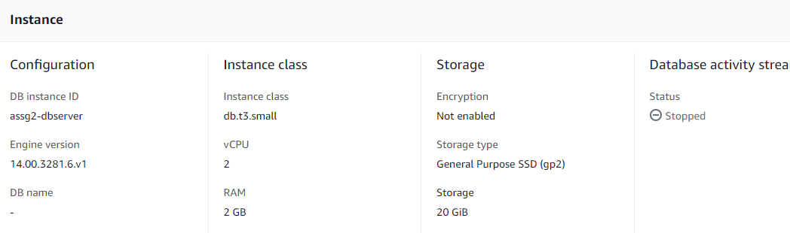

For the public subnet, its corresponding route table (Assg2_PublicRouteTable) has a target of the VPC's Internet Gateway (Assg2IGW) and a local target. The IGW gateway destination is set to 0.0.0.0/0, allowing all resources in the public subnet to access the internet. The local target has a destination of 10.0.0.0/16, which covers the IPv4 CIDR of the VPC, enabling all resources within the VPC to communicate with each other. On the other hand, the route table (Assg2_PrivateRouteTable) for the private subnets has an internal target, restricting communication to internal resources within the VPC and disallowing direct internet access.

**Assg2_PrivateRouteTable**

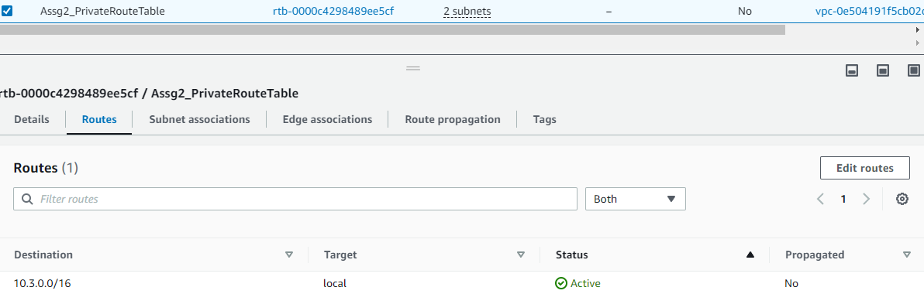

**Assg2_PublicRouteTable**

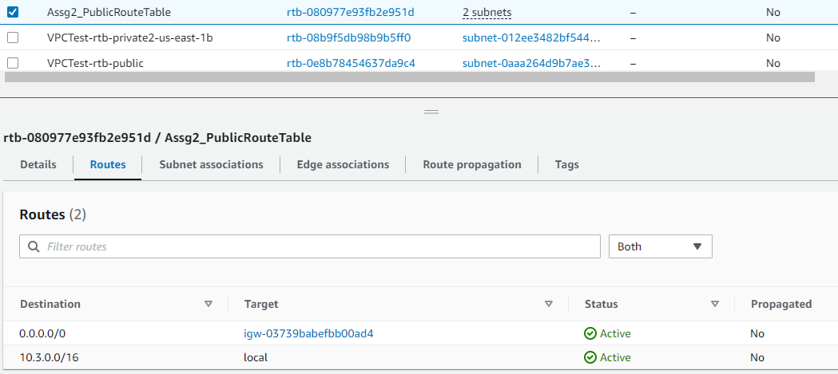

## 2.2 Load Balancer

Using an elastic load balancer (network load balancer) ensures that our AWS solution is scalable and can distribute network traffic across the various EC2 instances while maintaining security. This ensures smooth and efficient operation while ensuring appropriate resources are used depending on the network traffic. This makes the solution scalable and capable of meeting network demand while ensuring the safety of the data and user remains.

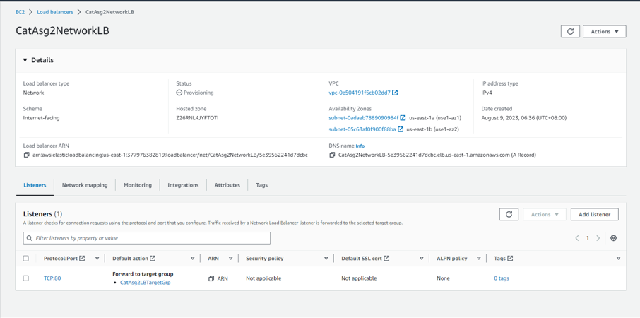

For example, if there is a sudden increase in network traffic, auto-scaling will initiate and generate more EC2 instances. The network traffic will then be directed across these EC2 instances through the load balancers to ensure the smooth and efficient operation of the service.

## 2.3 CloudWatch and SNS

Using CloudWatch, administrators can monitor AWS resources and services using metrics, alerts, and alarms.

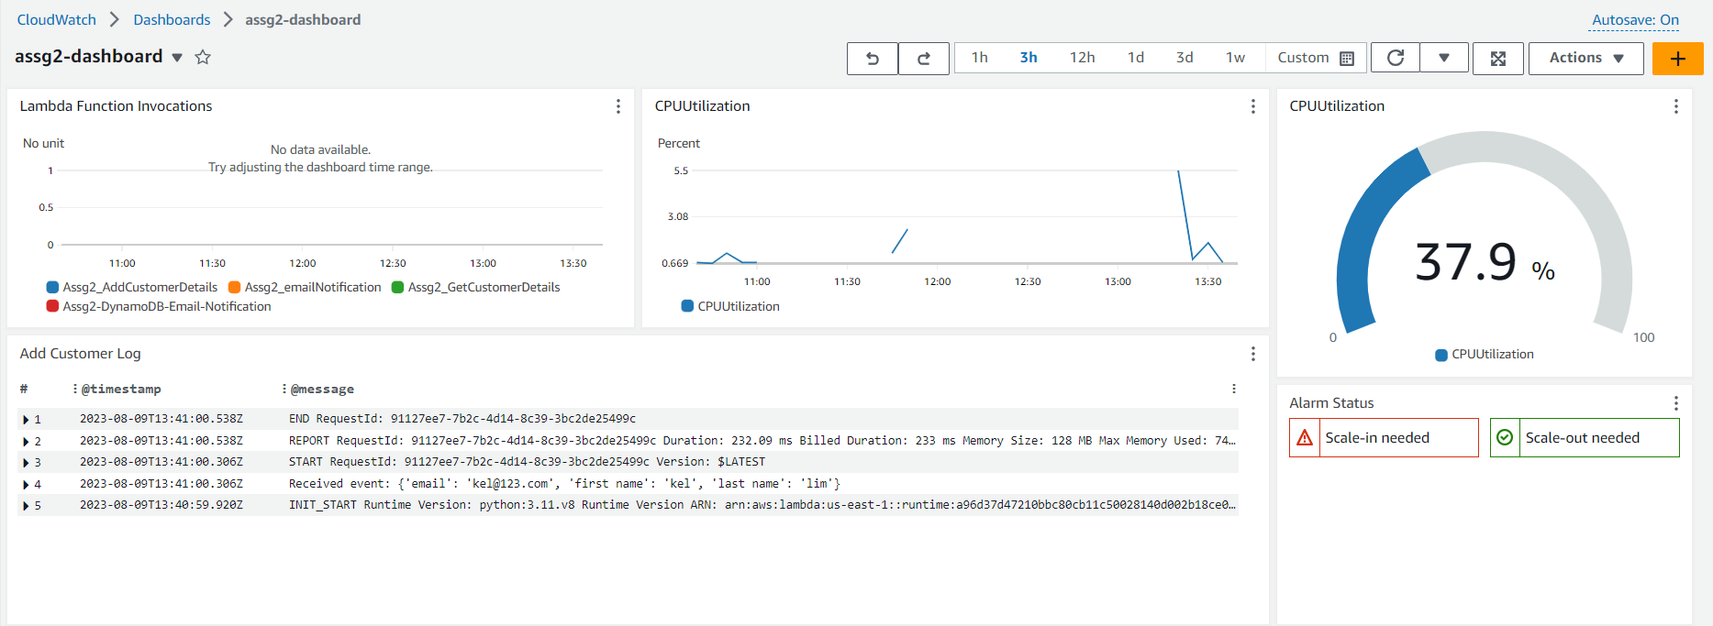

(^ dashboard metrics)

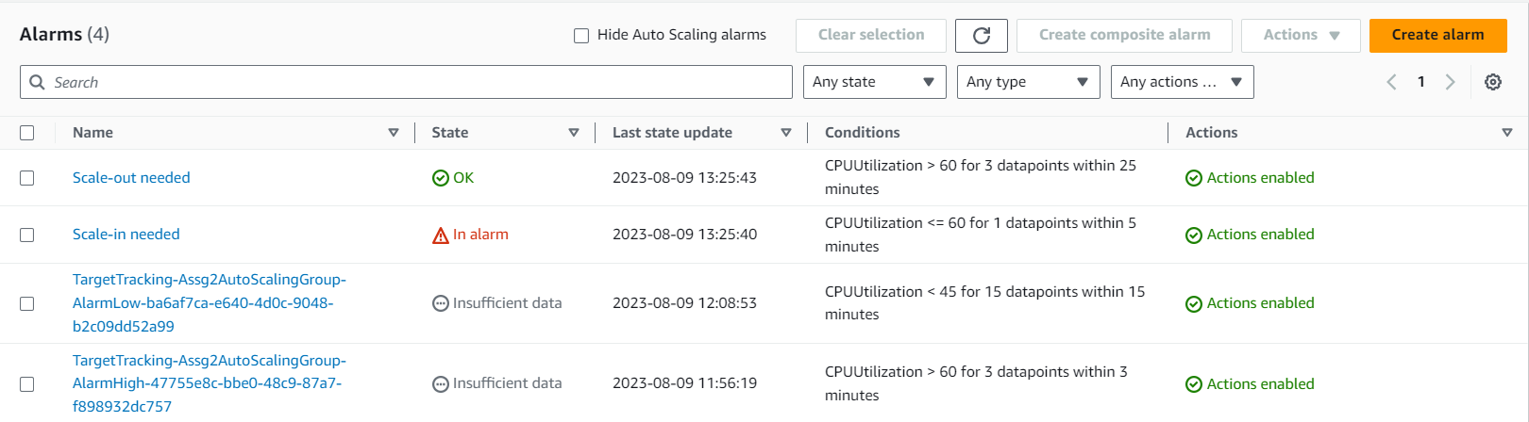

(^ alerts and alarms)

When an alarm occurs, a notification is sent to the administrators via SMS or email and automated actions, such as auto-scaling policies and Lambda functions will be triggered. For example, if an EC2 instance’s CPU utilisation is high, an auto-scaler is started to create more instances.

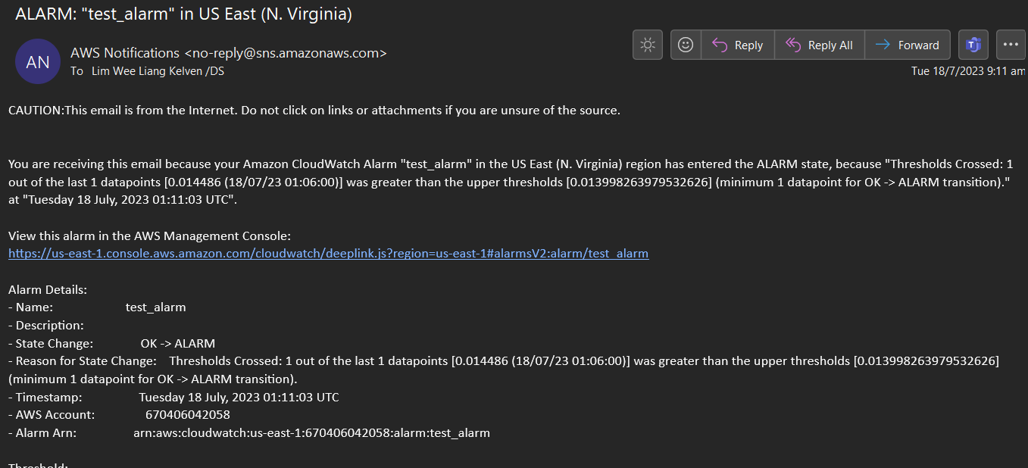

(^ CloudWatch email notification)

AWS CloudWatch also has a dashboard where administrators can customise what resources and services to monitor.

These monitoring, alerts, notifications, and automated actions are achieved through CloudWatch, SNS, and EC2 Auto-Scaling.

## 2.4 DynamoDB

DynamoDB, an AWS-managed NoSQL database service, is critical to the design of a serverless web application. The backend database stores and manages client information obtained via an HTML form. DynamoDB's versatility, scalability, and low-latency performance are ideal for our application. DynamoDB is used to store and manage client information obtained via the HTML form. Its key-value data model enables fast storing and querying of customer records, and its adaptive scaling features guarantee the database can manage a wide range of workloads. Customer names, contact information, preferences, and other relevant information are kept in DynamoDB to allow KVM Pte Ltd to efficiently communicate with its clients.

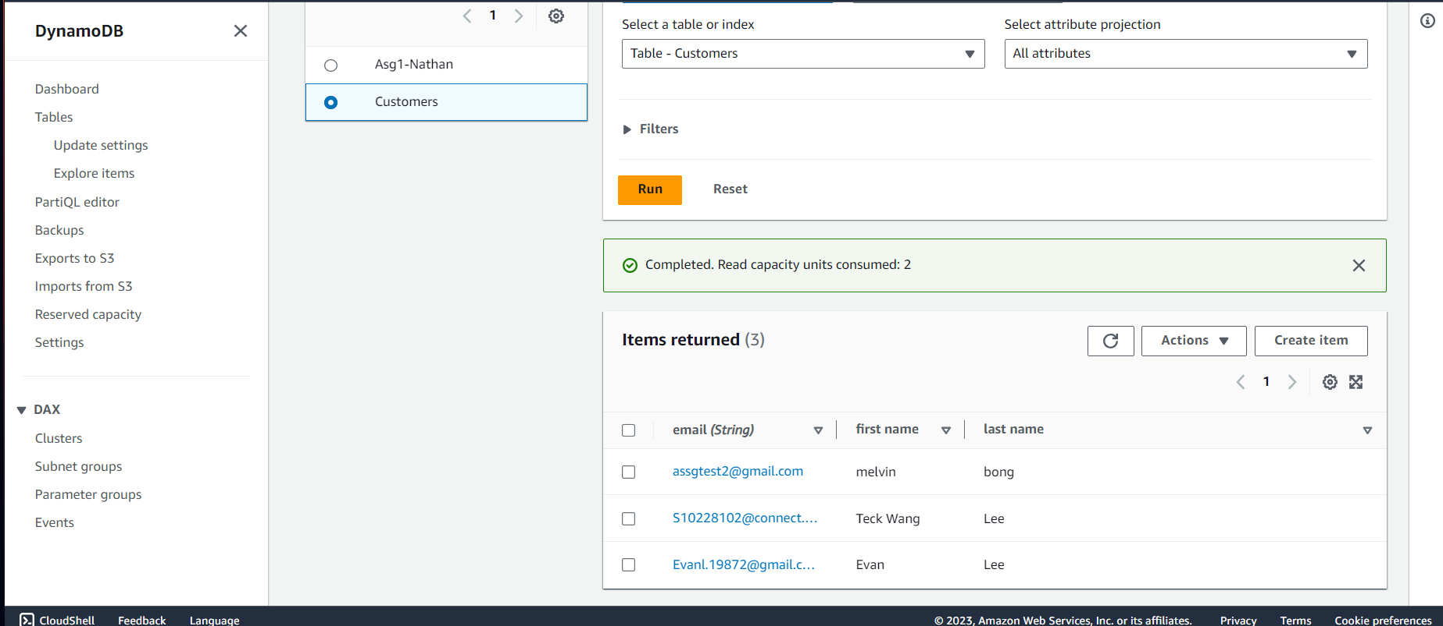

The DynamoDB created above has email as its partition key and firstName and lastName as attributes. Using email as the partition key ensures the user is unique as each email can only tie to one user.

## 2.5 HTML Forms Page

The HTML forms page is an interface for gathering consumer information. This webpage is an essential part of the user experience, allowing users to interact with the online application in real-time. The HTML forms page collects customer data such as first name, last name, and email address, and sends them to DynamoDB. The form is developed with a user-friendly style to make it easy for users to enter correct and comprehensive information. When the form is submitted, it triggers Lambda functions, API Gateway, and data storage in DynamoDB.

The screenshot of the HTML code is provided below. This image shows the <head></head> section of the HTML code which includes the stylesheet that would be used to design the form. This is important as the UI of the form should be appealing and enhance the UX.

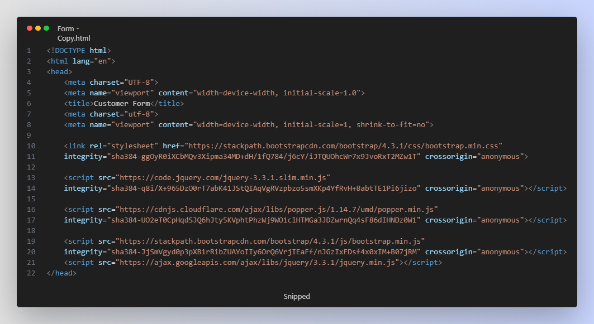

The image below is the body of the form which includes the text boxes for users to input the Email, First Name, and Last Name of the customer. It also creates a table that displays the existing customer information.

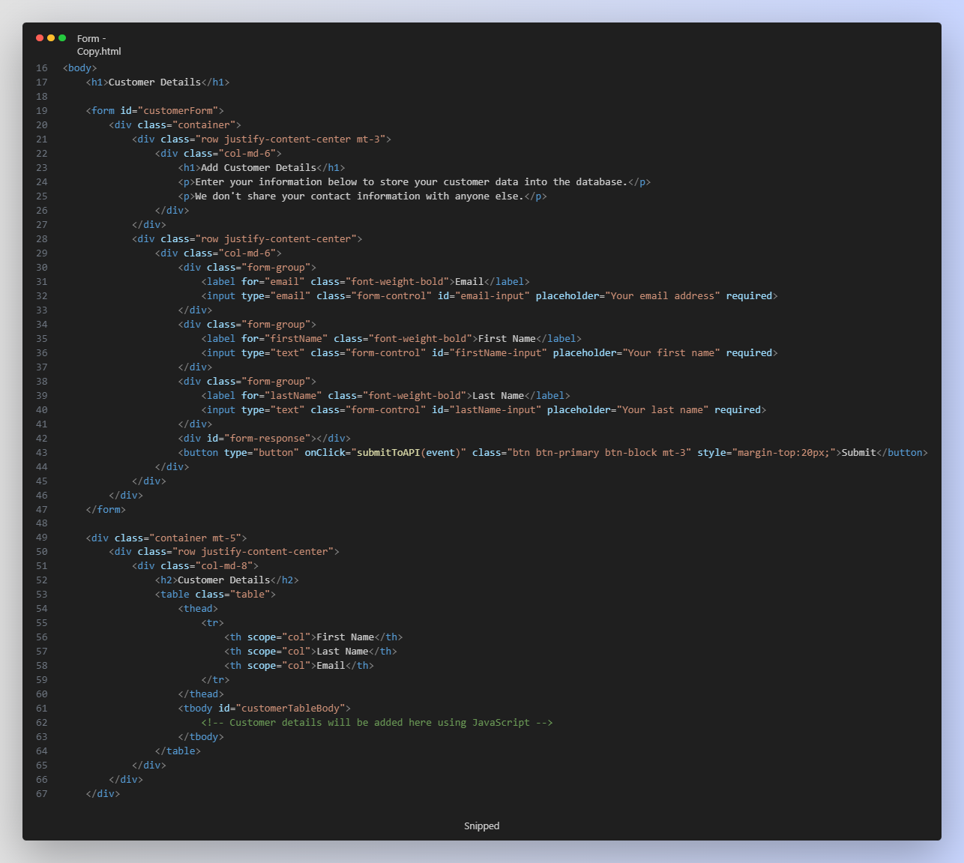

The last part of the code is using JavaScript to communicate with the API Gateway created in AWS. The function submitToAPI() is to add the information given by the user and parse it as a Json format. After the information is parsed as a Json format, the lambda function AddCustomerDetails will be triggered to store the data into the DynamoDB called Customers. The function fetchAndDisplayRecords() is used to communicate to the API Gateway to receive the information from the DynamoDB. Every customer detail should appear in the table if the table is not empty.

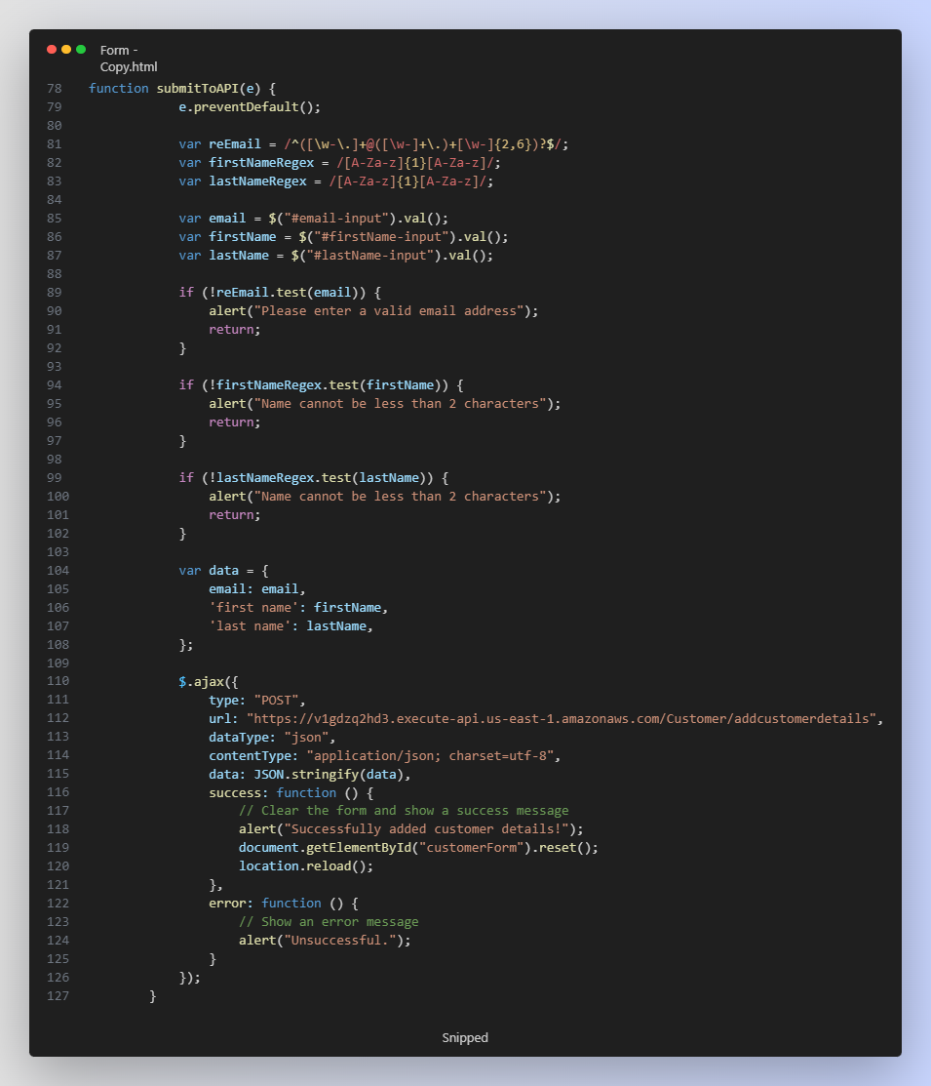

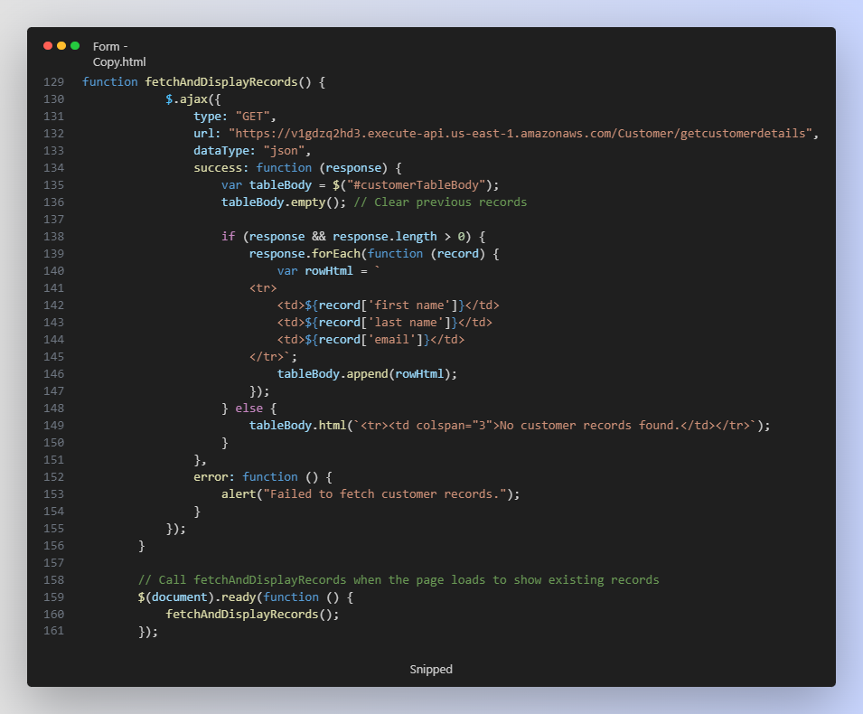

The image below is the form that is created from the HTML code. The HTML code is uploaded to the S3 bucket and hosted as a static website for users to access. [**Website Link**](http://assg2-bucket.s3-website-us-east-1.amazonaws.com)

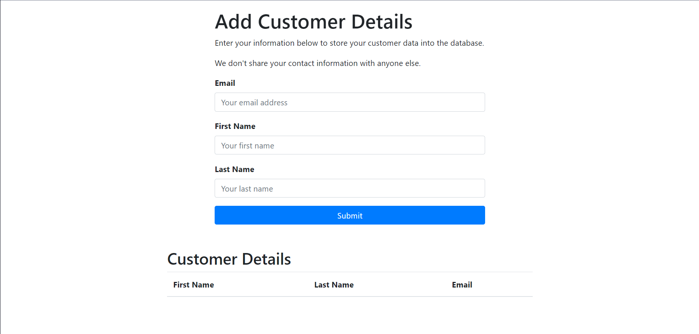

## 2.6 DynamoDB and S3 Notification

If new customer data are added to DynamoDB and when files are uploaded to an S3 bucket, an email notification is sent to the administrators.

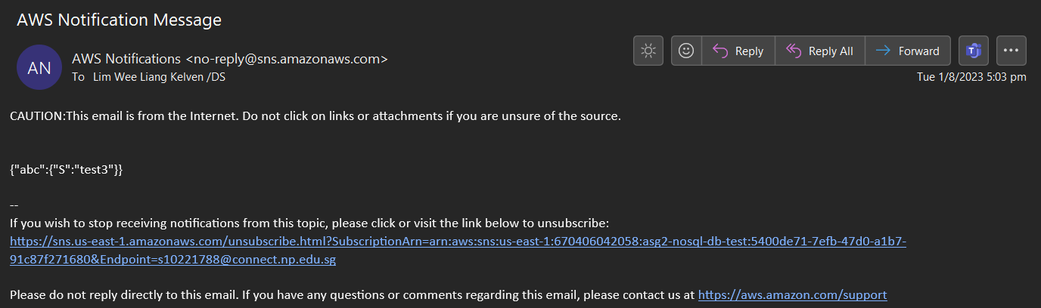

(^ DynamoDB email notification)

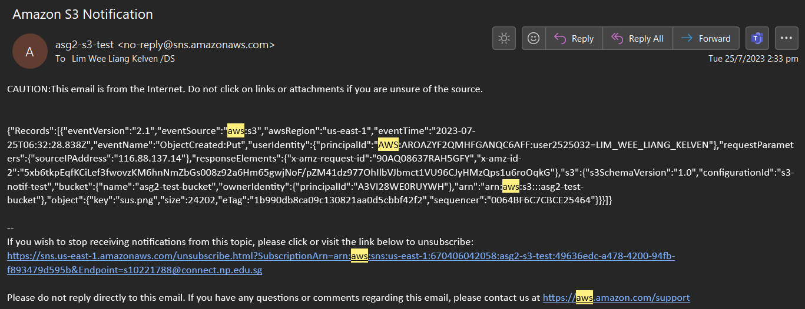

(^ S3 email notification)

For DynamoDB notification, this is achieved through SNS and Lambda. For S3 notification, this is achieved through SNS and S3.

# **3.0 Problems Encountered & Resolutions**

## 3.1 VPC and Auto-Scaler

The initial phase of the cloud solution progressed smoothly as most of the instructions for creating the EC2 Windows Server, internet gateway, and VPC were taught in the tutorials. However, during the setup of the VPC, I encountered a problem that revolved around understanding how the CIDR (Classless Inter-Domain Routing) would change based on the VPC IP. This issue led me to conduct some research to understand how CIDR's would change in the public and private subnets.

Through research, we understood how the CIDR changes according to the VPC’s IP address and how the CIDR represents a range of IP addresses assigned to the VPC. The CIDR's calculation relies on both the VPC’s IP address and subnet mask. Thus, VPC and subnets were appropriately configured using the CIDR.

## 3.2 Load Balancer

A load balancer was implemented alongside the auto-scaling groups. However, we learnt the load balancer had consumed several credits in the short time it was left running and leaving it running would inevitably use up our credits very quickly.

Our workaround is to suspend and remove it from the AWS cloud system first and only have it implemented as the very last stage of the development cycle for our AWS cloud solution to prevent the credits from being used up too quickly before the end of the assignment which ensures all other parts and components are fully implement and tested.

## 3.3 CloudWatch and SNS

The weekly practical sessions did not teach us about CloudWatch and SNS. Hence, it was difficult knowing where to start. Most of the time spent went towards watching online videos and researching documentation to understand how it works and what each feature does. It was also assumed that Lambda was needed because 2 of this project’s objectives were:

1. Implement Lambda functions to monitor events and trigger notifications.
2. Implement Lambda functions to run applications when triggered.

More time was spent figuring out how Lambda can be used to connect CloudWatch and SNS. It turned out that CloudWatch and SNS can function well enough without needing Lambda.

It was also theorised that Lambda was needed to increase/decrease the number of EC2 instances based on CPU utilisation. But after asking about this problem on a forum, we discovered that auto-scalers have dynamic scaling policies which function without needing Lambda.

Creating the dashboards and alarms was surprisingly simple and intuitive.

## 3.4 DynamoDB

The implementation of DynamoDB was smooth as it was a straightforward process that is guided by the steps outlined in the weekly practical sessions. There were a few issues during the set-up of the table which allowed us to complete the integration of DynamoDB smoothly.

## 3.5 HTML Forms Page

The development of the HTML forms page was an obstacle due to unfamiliar syntax and learning JavaScript to link user input to the backend systems. Learning new concepts and the approaches involved was arduous. Substantial effort was spent learning and understanding the code to collect and add data to DynamoDB utilising API Gateway and Lambda functions.

Setting up the API Gateway and Lambda was a challenge in and of itself. The process of integrating and configuring these components together with the HTML form and DynamoDB was complex. Creating the Lambda functions, GetCustomerDetails and AddCustomerDetails, was difficult as they required extensive testing and iterating to ensure the functionality corresponded to the expected output.

While the API Gateway and Lambda components were functioning during testing, a problem with the HTML form's “Submit” button was detected. Despite successful API Gateway and Lambda connectivity, the button did not perform as expected. The odd behaviour caused more delays and research into the JavaScript routines in charge of form submission. Solving the root cause of this problem was challenging but was solved after a few days of hard work. The issue is due to the JavaScript code that was supposed to communicate with the API URL.

## 3.6 DynamoDB and S3 Notification

In our weekly practical sessions, there was a noticeable absence of instruction regarding the utilisation of SNS for notifications and the integration of DynamoDB and S3 with SNS and Lambda. This gap in our curriculum necessitated a significant investment of time in external resources such as online videos and documentation to grasp the functionalities and features of these services.

For DynamoDB, the notifications required Lambda and identity access management (IAM). The Lambda codes were referenced from online videos and documents. But for IAM, our student accounts could not create new roles or alter permissions from existing roles. After consulting with the teachers, it was discovered the existing LabRole had permissions for DynamoDB and SNS. After some configurations, the email notification worked.

For S3, we had to edit the SNS topic’s Access Policy using a code found online and create an event notification in the S3 bucket. These 2 steps linked S3 to SNS and the email notification worked.

## 3.7 Resize images

This was an additional requirement to create a serverless function to resize images from a S3 bucket. The initial setup was simple as there was an AWS tutorial. However, after setting up the environment in the zip file and placing it in the lambda function, the function kept returning errors. Due to time constraints, we were unable to deploy this optional requirement.

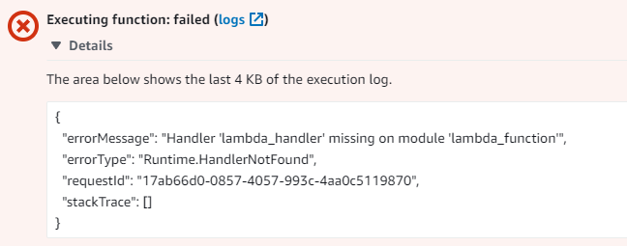

# **4.0 How the Requirements are Implemented**

## 4.1 VPC, and Load Balancer

To meet the requirements, a Virtual Private Cloud (VPC), VPC-Team3, was created and attached to the Internet Gateway, Assg2IGW, to enable internet communication for the resources within the VPC.

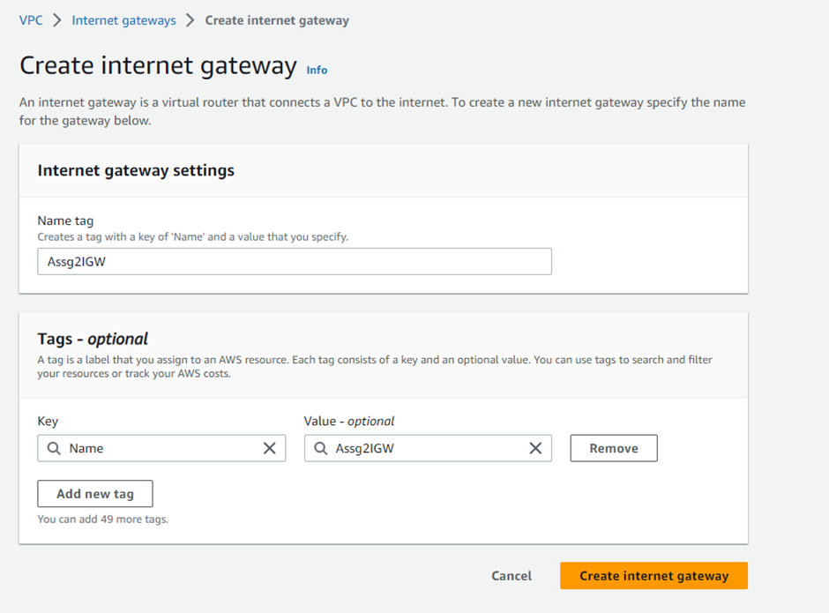

The VPC CIDR was set to 10.3.0.0/16 following the assignment requirements for team 3.

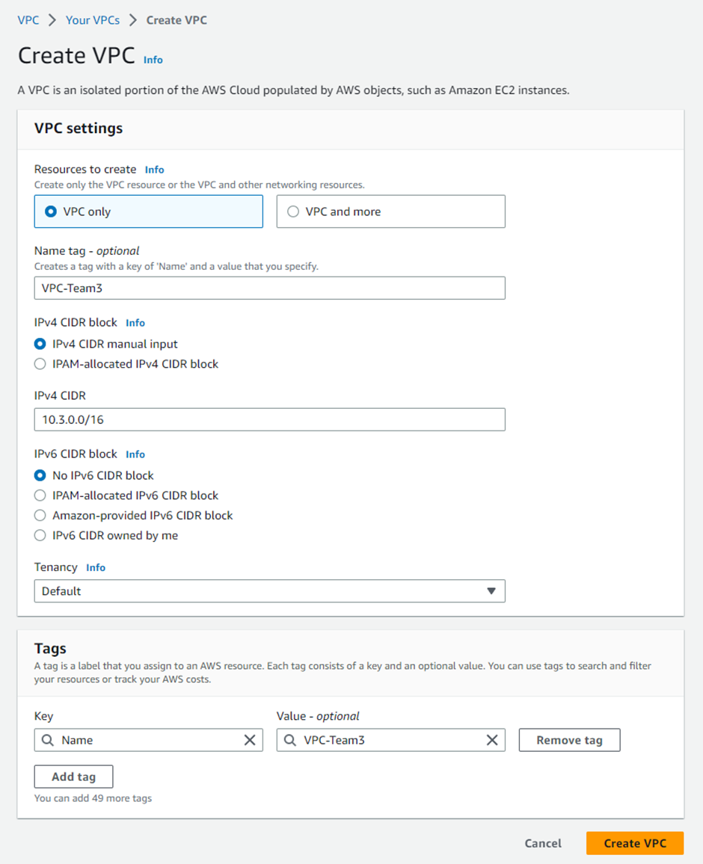

The VPC was designed to span across 2 availability zones (AZ), us-east-1a and us-east-1b, to enhance resiliency and fault tolerance. 2 public and private subnets were set up in different AZs for the RDS database, prioritising security.

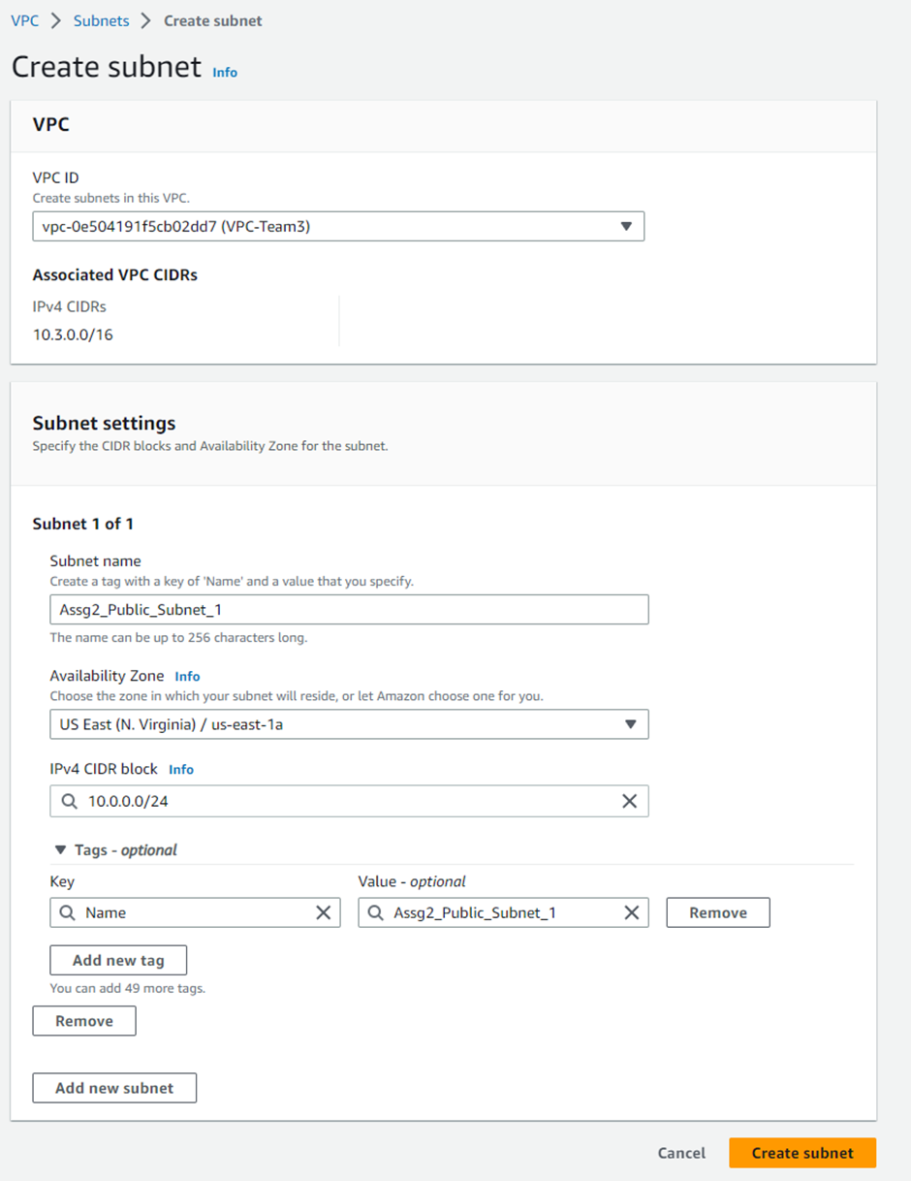

Additionally, “auto-assign public IPv4 addresses” was enabled to connect the public subnets to the internet.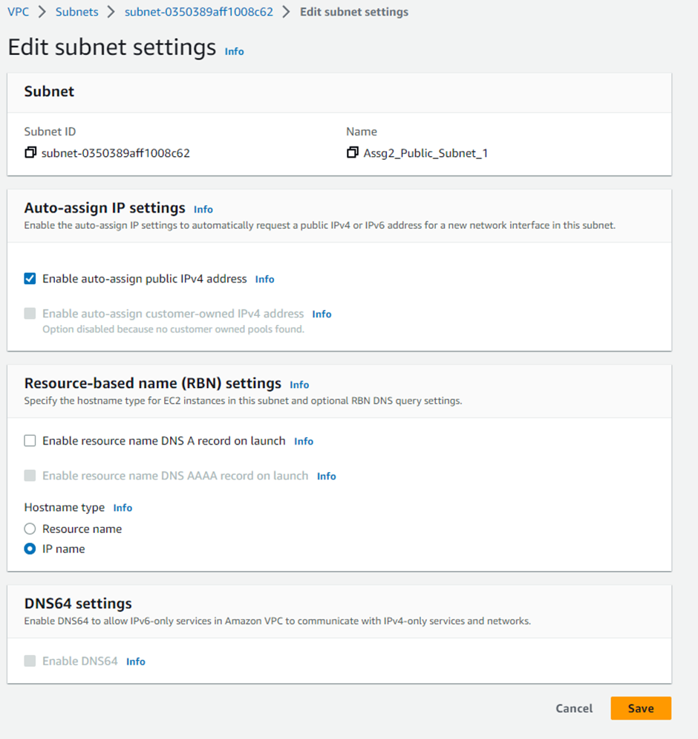

The route table for the public subnets had the target Internet Gateway, Assg2IGW, with a destination 0.0.0.0/0 to enable resources in the public subnets to access the Internet and communicate with each other within the VPC. The private subnets' corresponding route table had an internal target, ensuring that communication within the private subnets remained internal and private.

**Public Route Table**

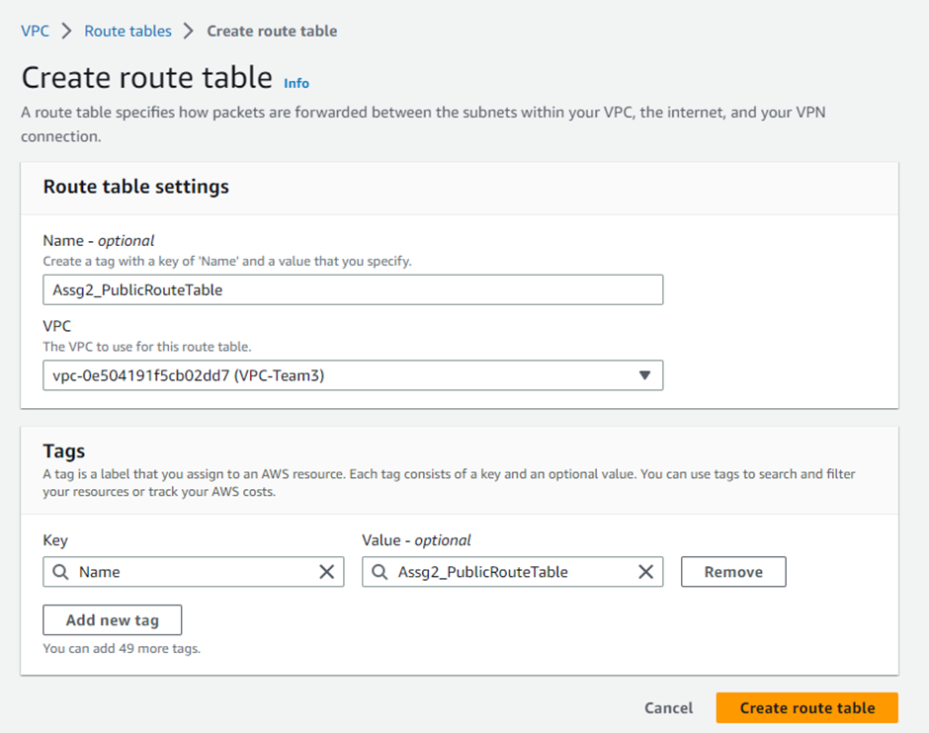

**Target Internet Gateway**

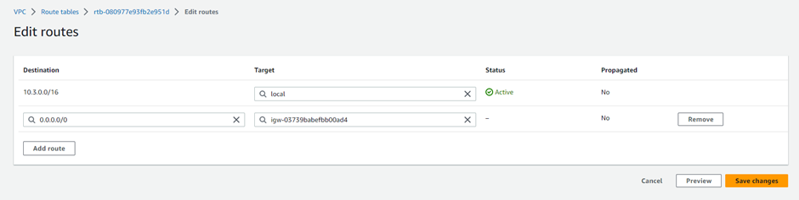

**Private Route Table**

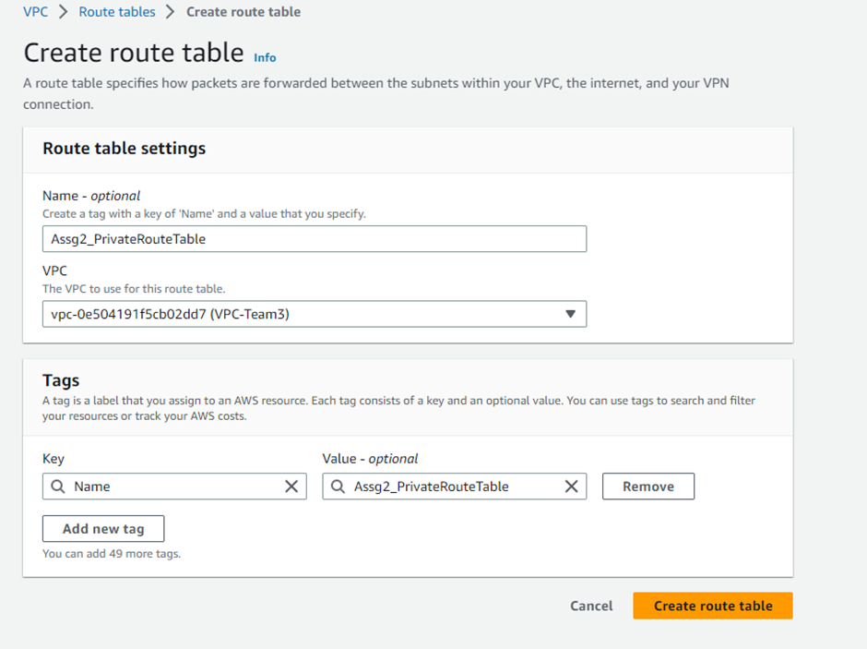

For the EC2 instance, a Windows Server template was created using Microsoft Windows Server 2019 Base AMI and t2.micro instance type. The instance was connected to the VPC-Team3 in one of the public subnets, and a public IP address was auto-assigned. The Key Pair, MyEC2Keypair, was used for the EC2 instance.



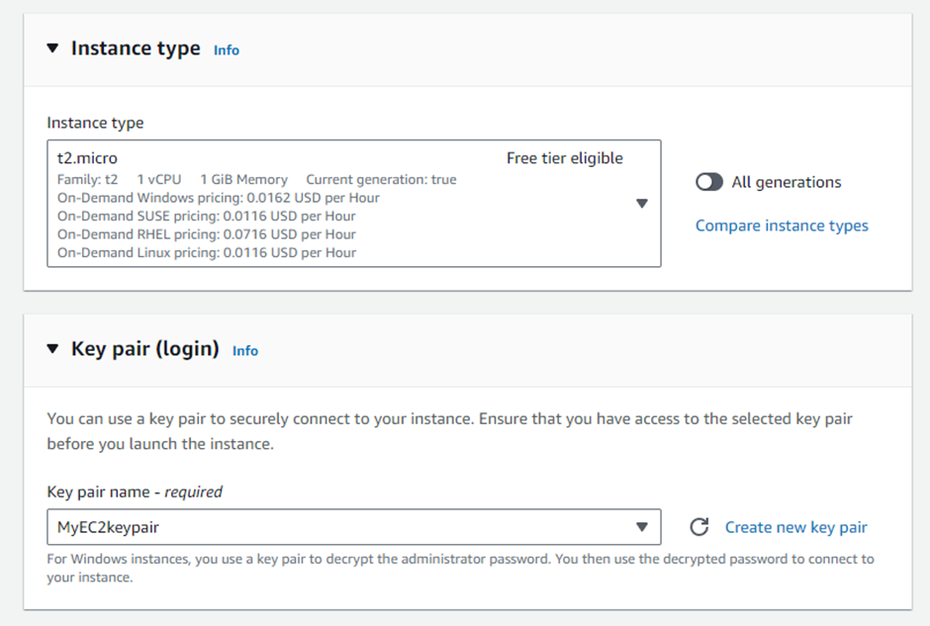

A new security group, Assg2_SgWebServer, was created to allow access via RDP, HTTP, HTTPS, MSSQL, and All ICMP-IPv4 protocols.

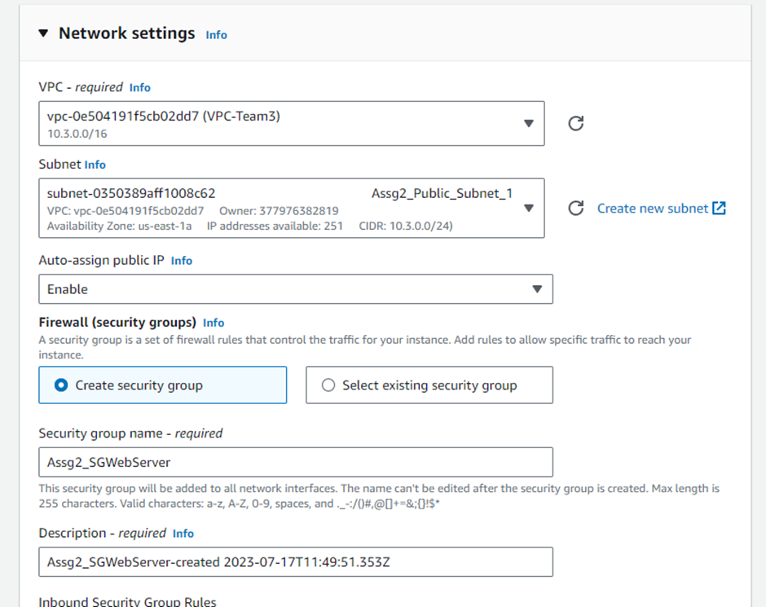



The EC2 instance was configured with 30 gigabytes of general-purpose storage. 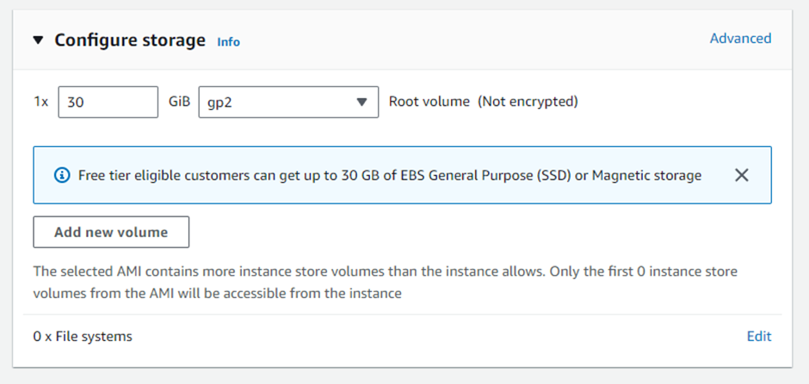

Once the EC2 instance was set up, the “Get Windows password” function was used with the EC2 key to get the Windows password for the RDP. After retrieving the password, the EC2 instance was accessed using the public IPV4 and RDP and necessary software tools such as the 7-zip utility application was installed. The web server role, its features, and Microsoft .NET Core 2.2 were installed to set up the default website. The web service was configured using the Internet Information Services (IIS) Manager, and the provided published web application files were deployed to the wwwroot folder of the EC2.

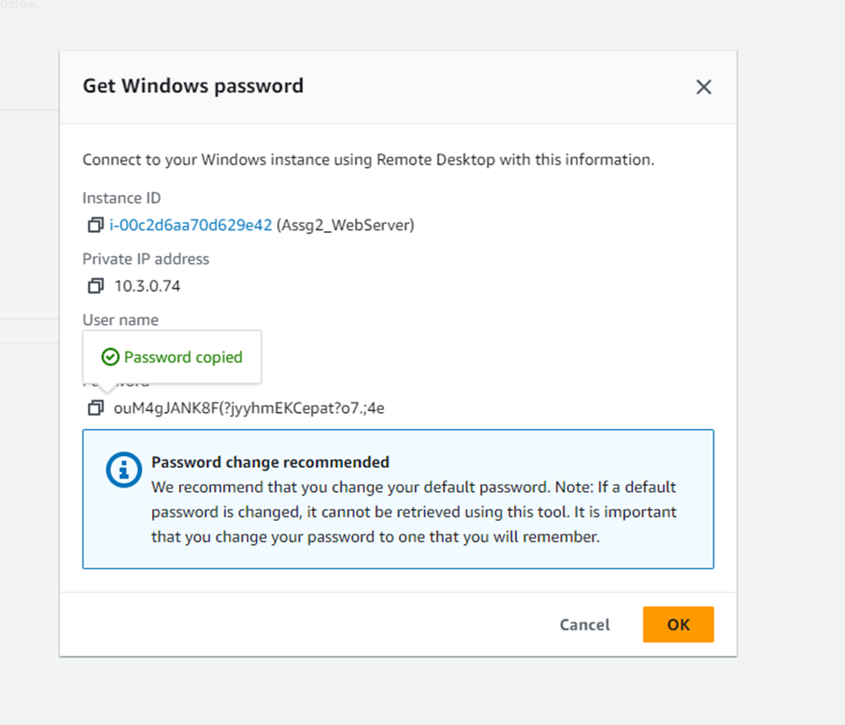

An RDS instance was created to connect to the Windows server. The RDS instance resided within the VPC-Team3 and operated in the private subnets across two AZs. The inbound rules of the security group attached to the RDS instance were modified to allow all traffic, ICMP and MSSQL traffic from anywhere. After installing and setting up Microsoft SQL Management Studio on the EC2 instance, the instance was connected to the RDS using the RDS endpoint, master ID, and password. The provided SQL script was executed to properly configure the database and adjusted the application connection string to establish successful communication between the EC2 and RDS, resulting in a functional website.

To enhance the availability and scalability of the EC2 server, a load balancer (Assignment2) was set up using VPC-Team3 and the 2 AZs as the network mapping. Specifically, a network load balancer was used as it distributes incoming TCP and UDP traffic across multiple targets such as EC2 instances, microservices, and containers. When the load balancer receives a connection request, it selects a target based on the protocol and port that are specified in the listener configuration, and the routing rule specified as the default action.

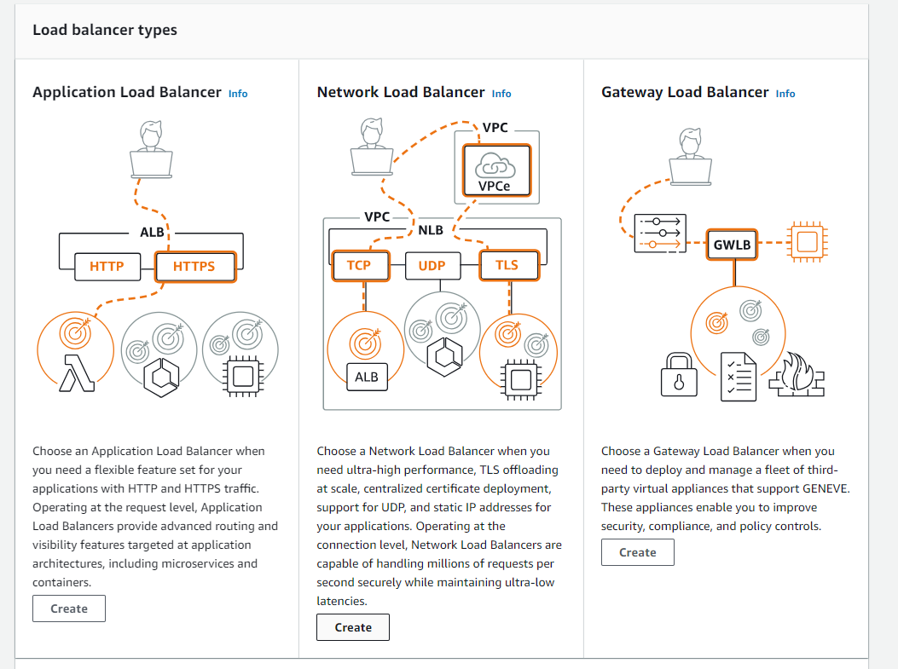

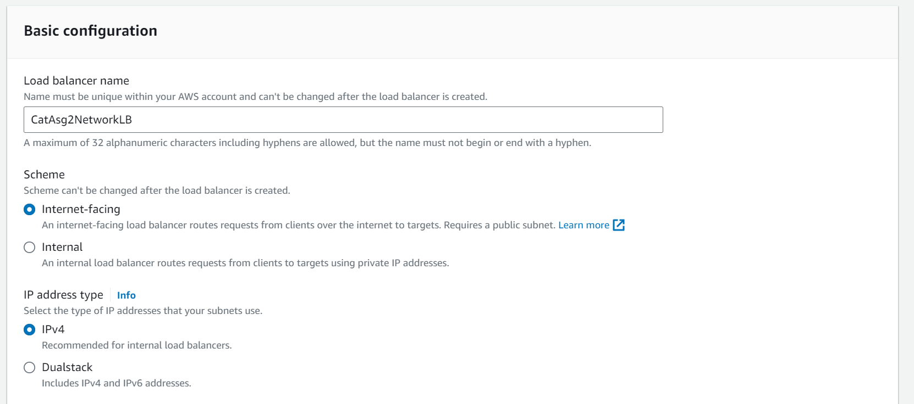

The load balancer was configured to be internet-facing and using the IPv4 address type.

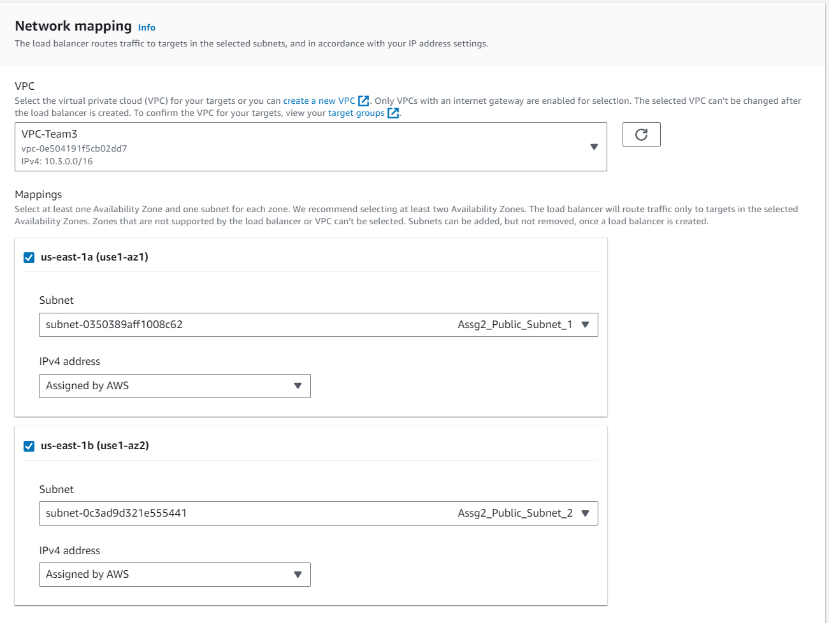

This load balancer was mapped to both public subnets in both AZ in the VPC-Team3 to enhance scalability and availability which allows the system to cope with traffic demand.

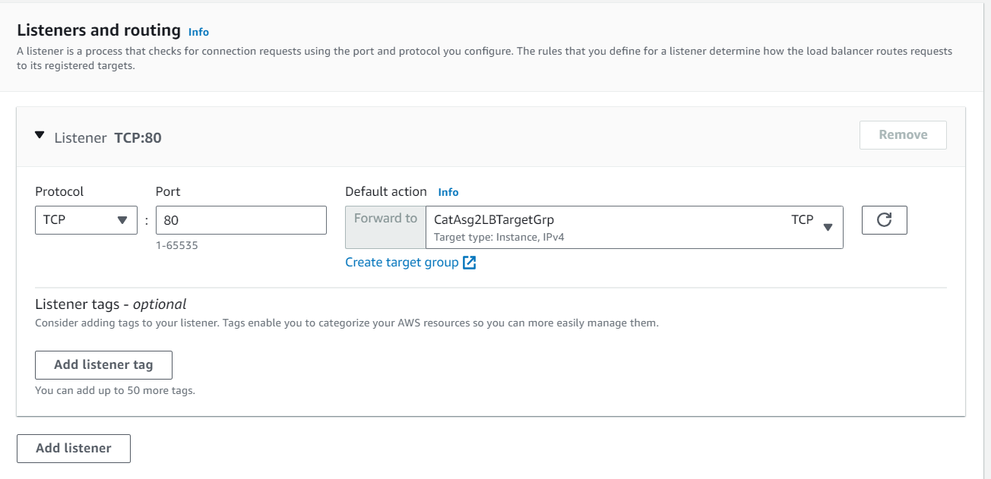

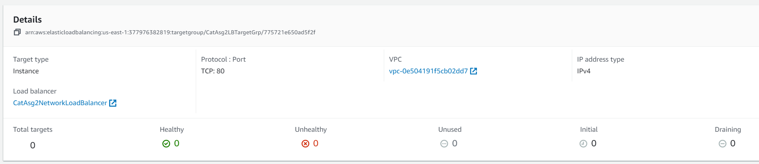

The appropriate target group was also added as part which was set on the instance section.

For better management and resource utilisation, an AMI image of the EC2 server was created and created an auto-scaling group based on the AMI. The auto-scaler was configured to scale out and scale in to maintain an average CPU utilisation of 60%, ensuring optimal performance and cost efficiency and enabling the web application to handle varying levels of traffic demand seamlessly.

## 4.2 Auto-Scaler

We implemented the auto-scalers with a target tracking policy at 60% utilization to scale up from 2 and scale down when not needed. This ensures the web application has the resources it needs to handle traffic spikes, while also minimising costs when there is low demand.

This ensures the auto-scaling group always has the right number of instances to meet the demand for the web application. When there is high demand, the auto-scaler adds instances to the group to handle the load. When there is low demand, the auto-scaler removes instances from the group to save costs.

The target tracking policy is a more dynamic way to scale than a step scaling policy. A step scaling policy will add or remove instances in fixed increments, regardless of the current load on the application. A target tracking policy will add or remove instances in a way that keeps the CPU utilisation of the auto-scaling group close to the target value.

This means the target tracking policy is more responsive to changes in demand. It will also help to avoid over-provisioning or under-provisioning of resources.

We believe the implementation of the auto-scalers with a target tracking policy at 60% utilisation will provide a highly available, resilient, and cost-effective way to host our web application in AWS Cloud.

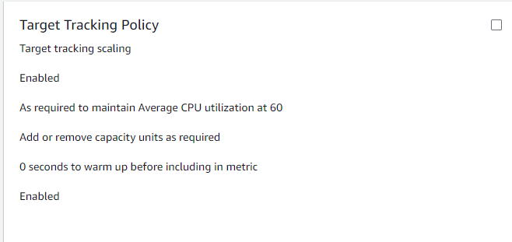

## 4.3 CloudWatch and SNS

### 4.3.1 Create SNS Topic

For KVM Pte Ltd to receive any form of notifications and alarms, a new SNS topic was created.

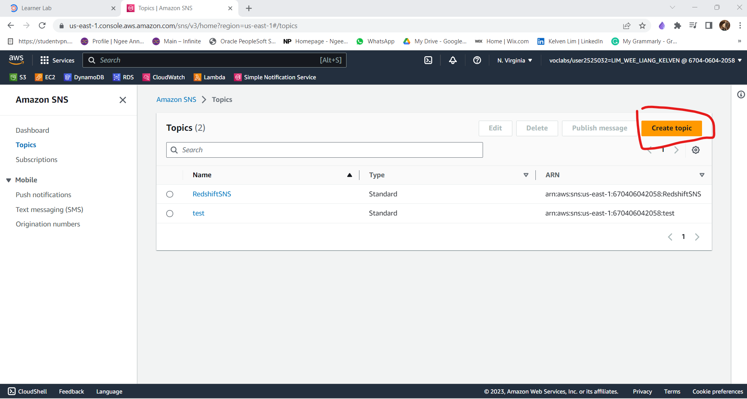

When creating the topic, the “Standard” type was selected and it was named, “

topic-Assign2CAT” before creating.

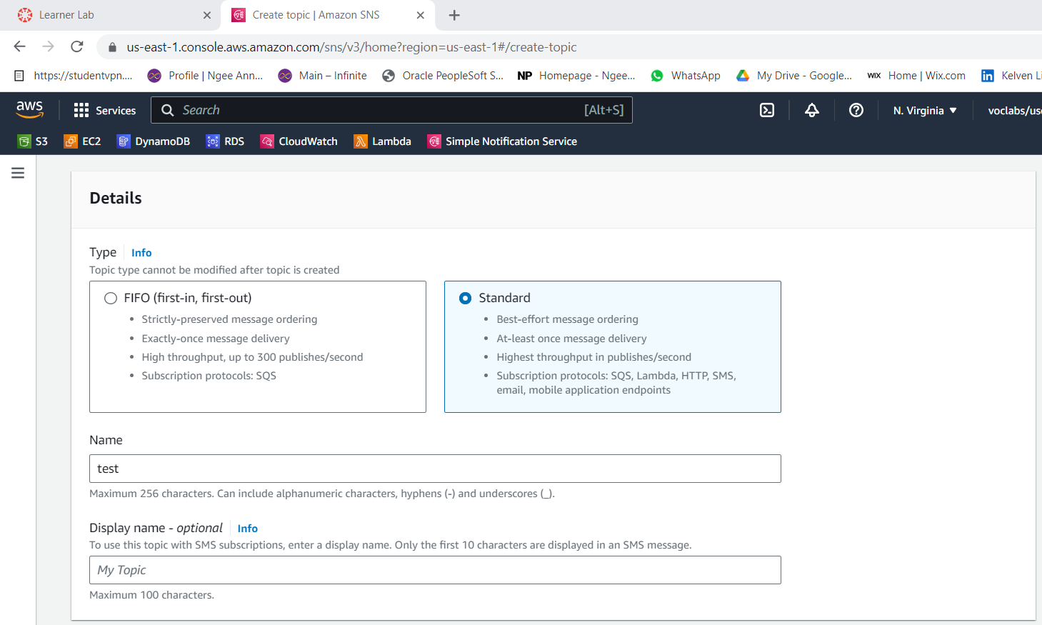

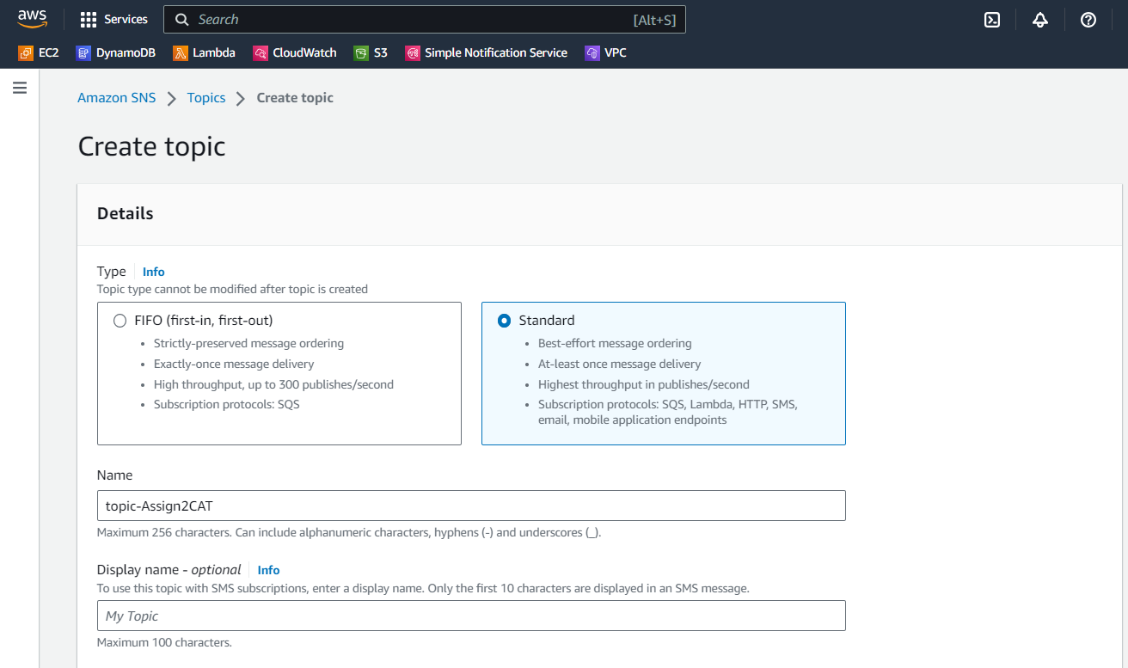

Once the topic is created, a new subscription was created.

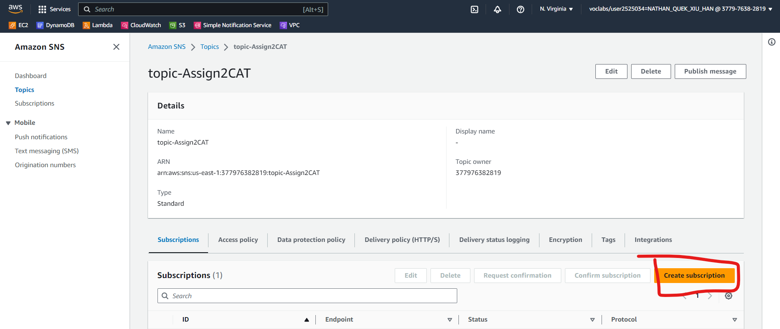

The “Topic ARN” should be your created topic by default. “Email” was selected for Protocol and enter your email and click on Create subscription. Leave the other options as is.

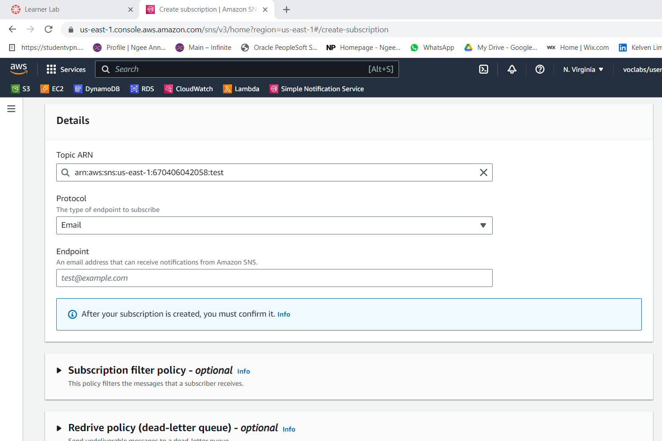

In the email inbox, an email was sent to confirm the subscription.

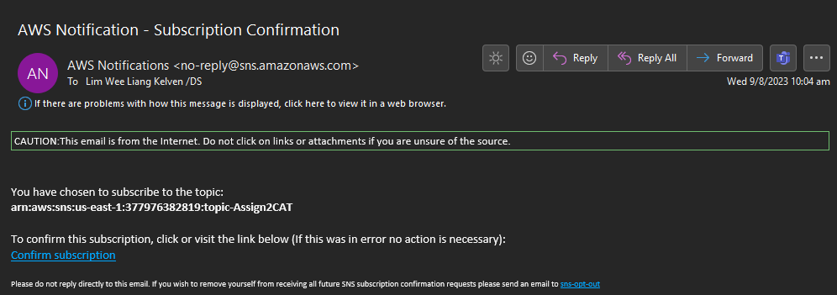

### 4.3.2 Create CloudWatch Dashboard

To monitor the web application and other AWS resources and services, a dashboard was created using CloudWatch. This dashboard is customisable to show critical metrics, alarms can be set up for different metrics, and these alarms can trigger automated actions.

The new dashboard was named “assg2-dashboard”.

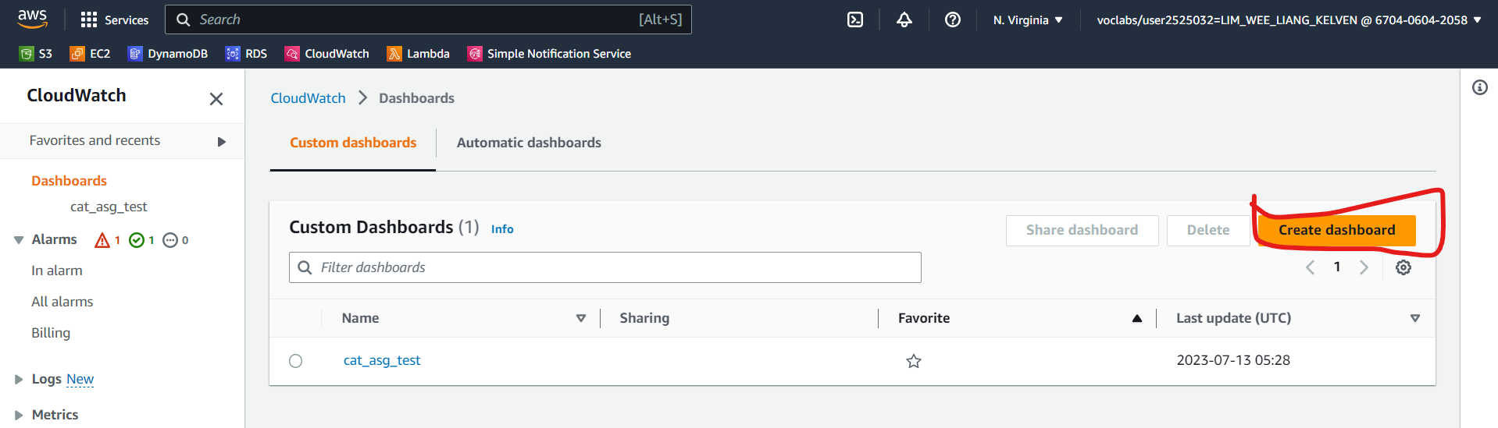

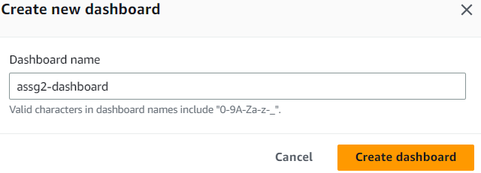

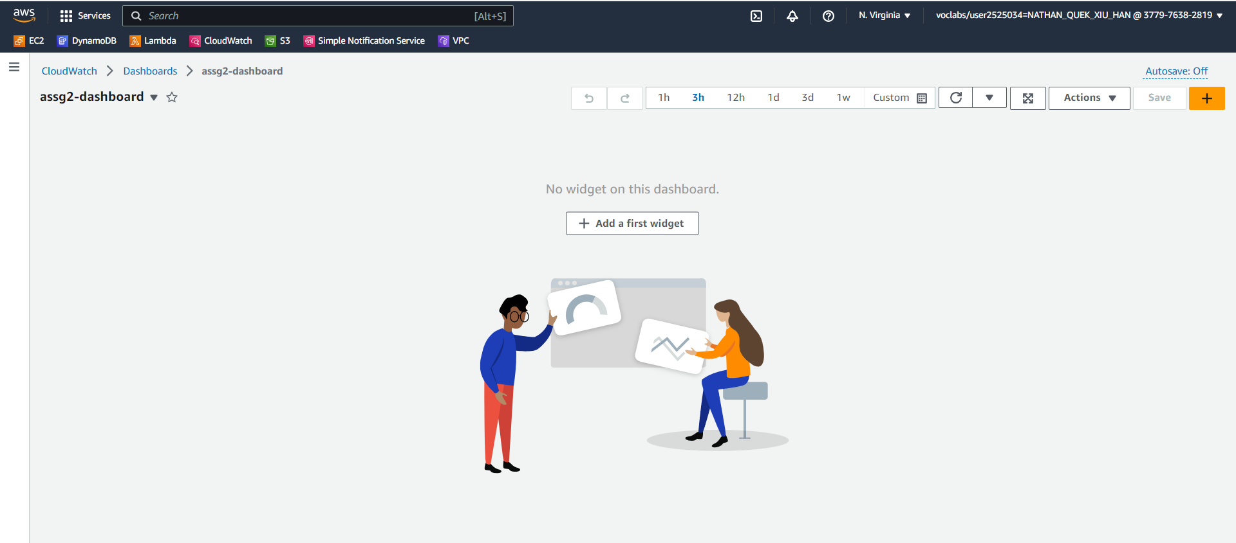

After adding some widgets, this is what the customised dashboard looks like.



There are 5 charts. From the top left going clockwise, the first is a line chart showing the number of invocations of each Lambda function.

The second is a line chart of the CPU utilisation of each instance.

The third is a gauge showing the CPU utilisation of the auto scaler. If it hits 60%, an email notification will be sent, and automated actions will be triggered.

The fourth shows the state of each alarm. Since CPU utilisation is less than 60%, the Scale-in needed alarm is in alarm while Scale-out needed is ok.

The fifth chart shows the recent log activities.

### 4.3.3 Create CloudWatch alarm

If the EC2 instance’s CPU utilisation reaches 60%, the auto-scaler will create more instances. 2 alarms are created, one for scaling-out, and the other for scaling-in

In CloudWatch, a new alarm is created.

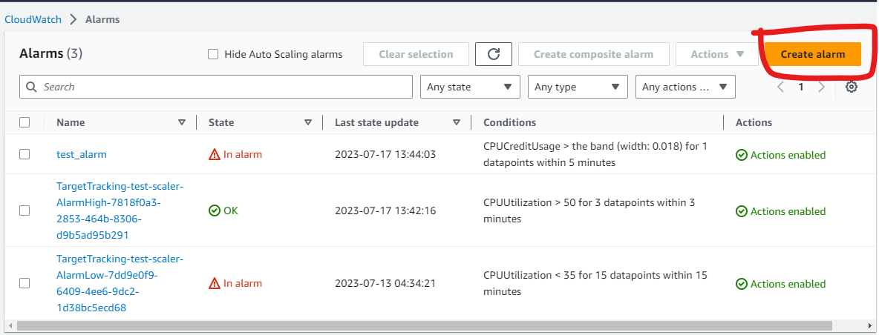

Under **EC2 🡪 Assg2_WebServer_Original CPUtilization**.

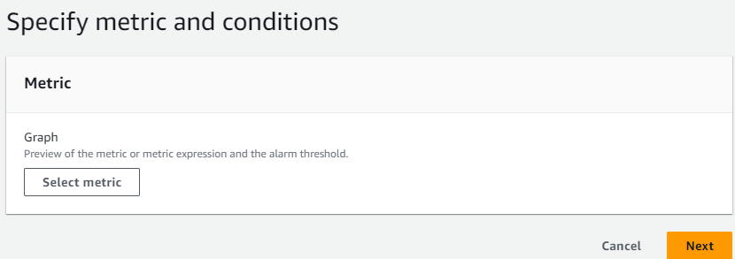

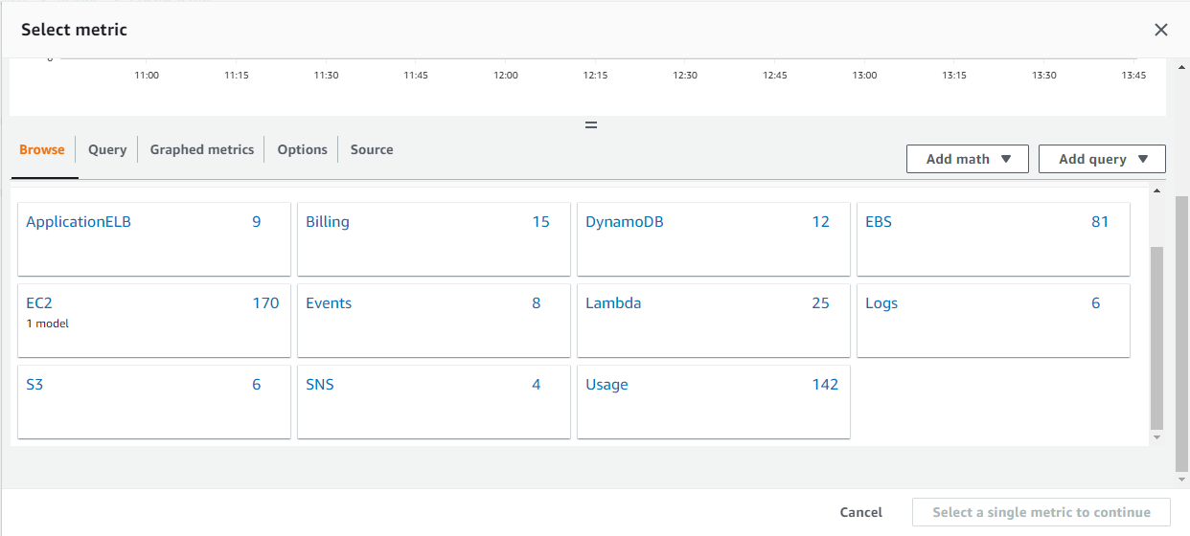

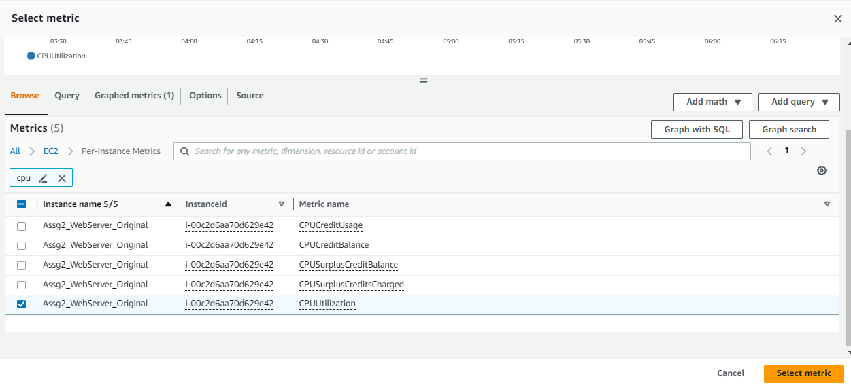

“Average” was chosen for Statistic, “5 minutes” for the Period, “Static” for Threshold type, greater than 60, and 3 out of 5 data points to alarm.

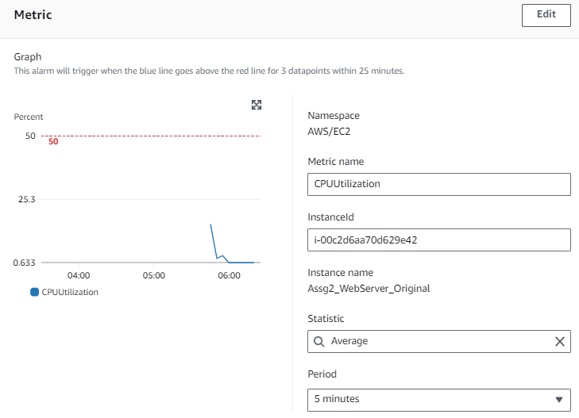

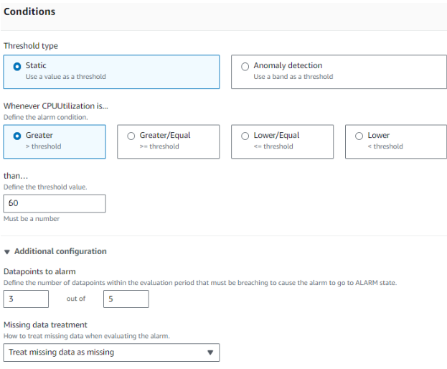

“In alarm” was chosen for Alarm State Trigger, “Select an existing SNS topic” and “topic-Assign2CAT” were chosen.

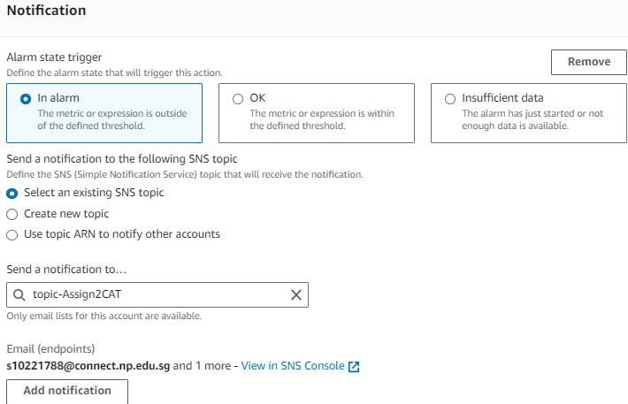

The alarm is called Scale-out needed.

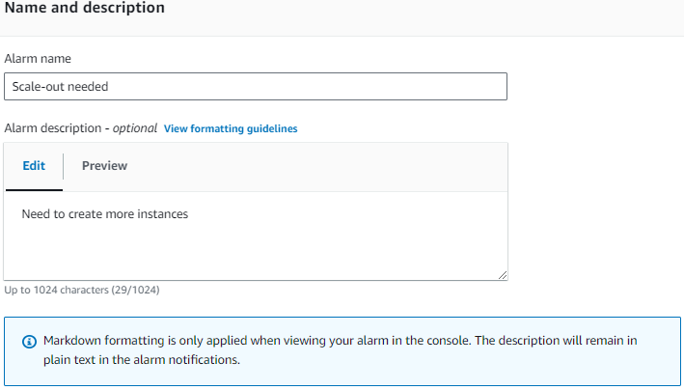

For the other alarm, some steps were similar. Thus, only the different steps will be shown.

When selecting the threshold conditions, choose Lower/Equal than 60.

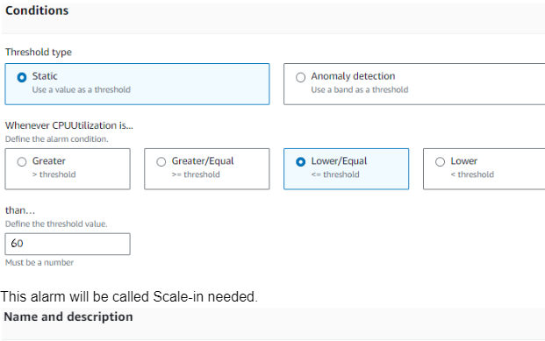

This alarm will be called Scale-in needed.

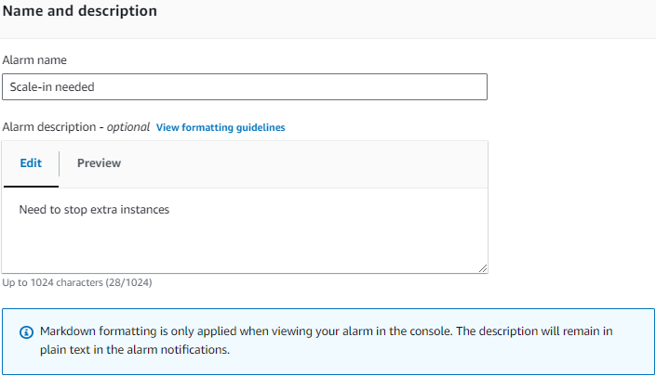

You should see your alarms in the list.

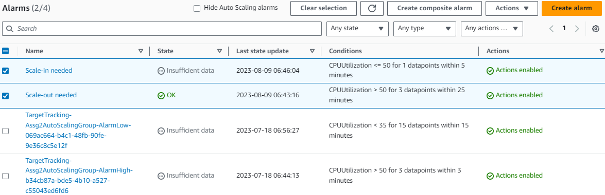

### 4.3.4 Activate auto-scaler based on CPU utilisation

This step creates the auto-scaling policies so the auto-scaler will trigger when CPU utilisation reaches 60%.

Select the auto-scaling group created. Under the Automatic scaling tab, go to Dynamic scaling policies and create a new dynamic scaling policy.

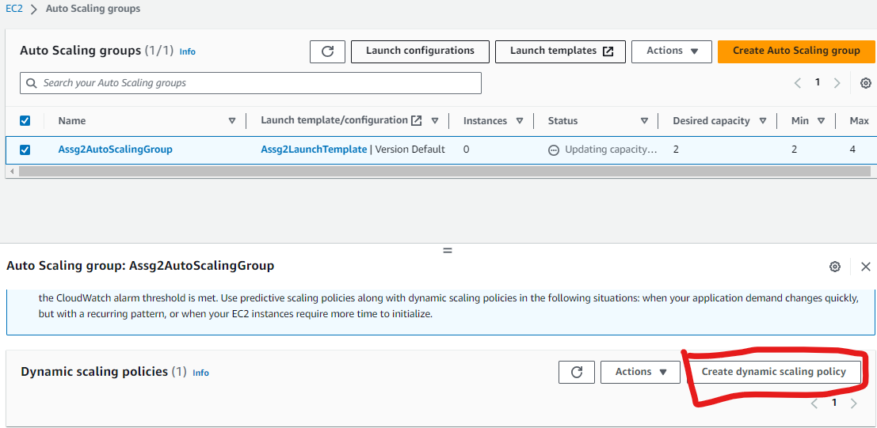

For Policy Type, select Step scaling. For the name, enter “Scale-out needed”. Select the “Scale-out needed” alarm created previously. Set the action to “Add”, enter “2” for capacity units, and put “0” for warm up.

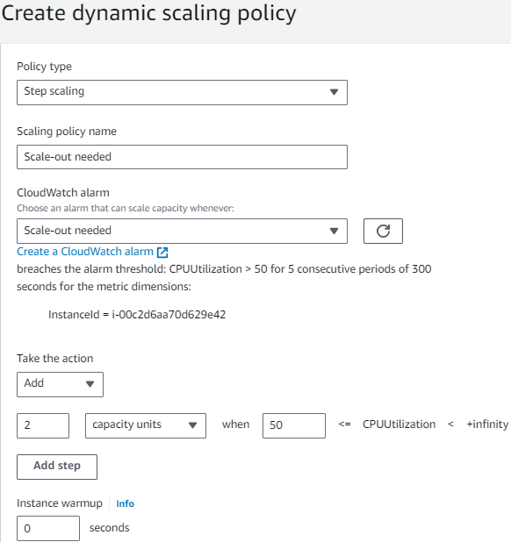

Create another policy, called “Scale-in needed”. Follow the previous step. But for Action, select “Remove” and put “2” for capacity units.

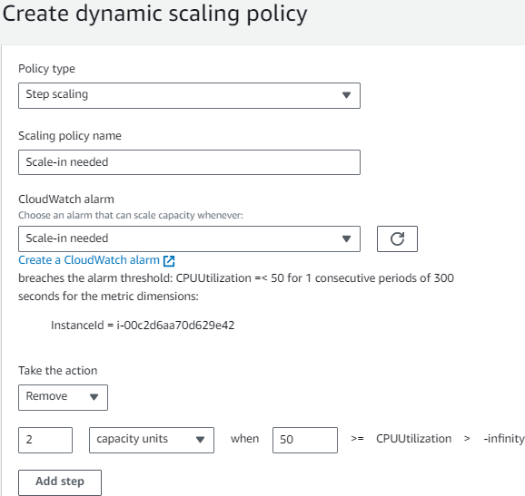

## 4.4 DynamoDB

A DynamoDB is created to store customer data.

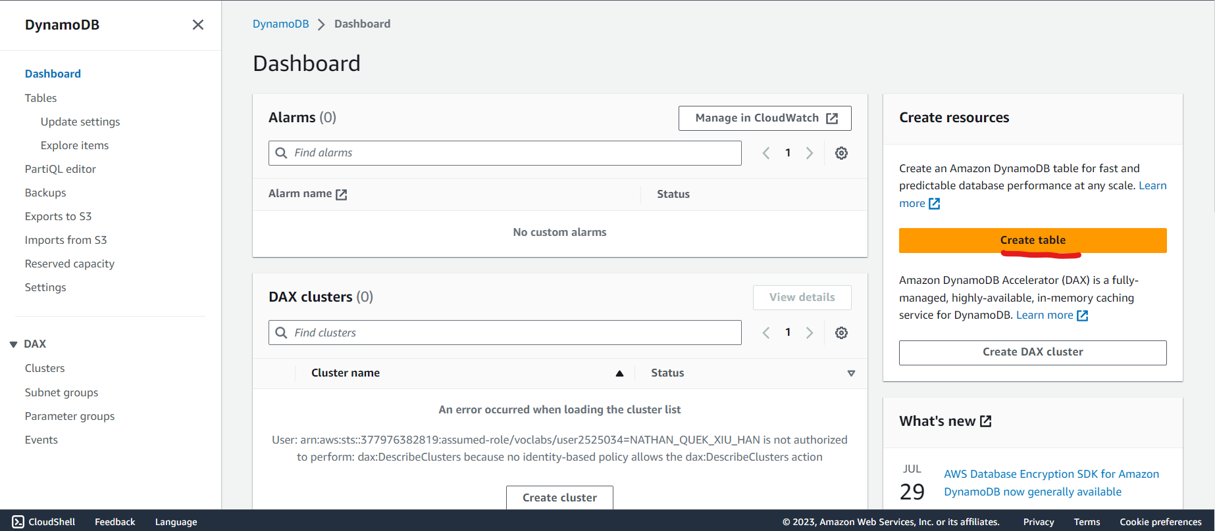

The table is named Customers, name its Primary/Partition key “email”, and select the data type as "String". Primary keys uniquely identify each item for this example, we can use the "email" field as the primary key since it's unique for each customer. 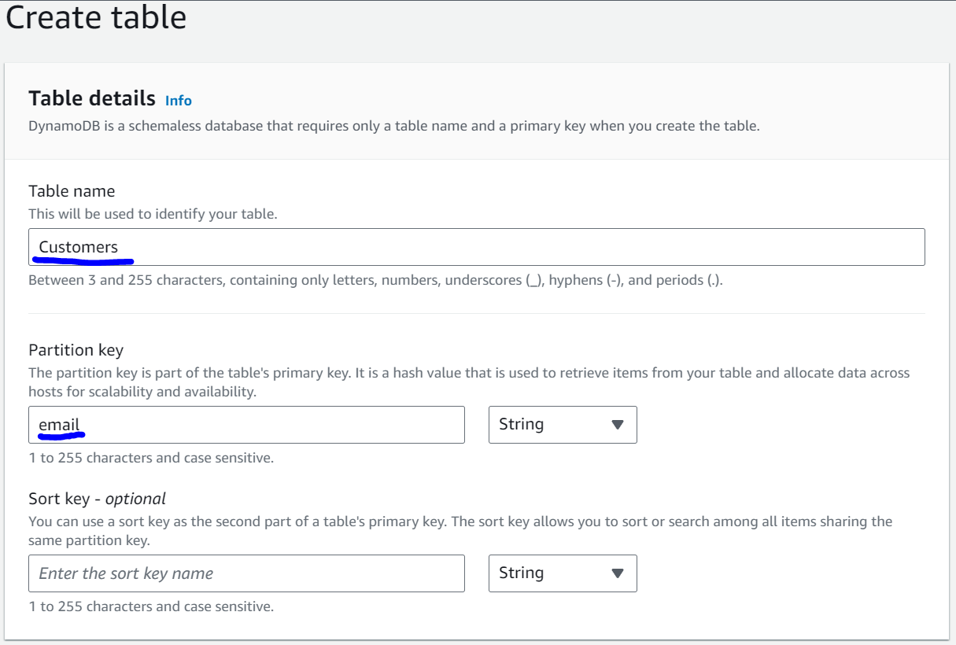

DynamoDB allows users to choose between provisioned capacity (where you specify read and write capacity units) or on-demand capacity (automatic scaling). For simplicity, "On-demand capacity" was chosen to automate capacity management.

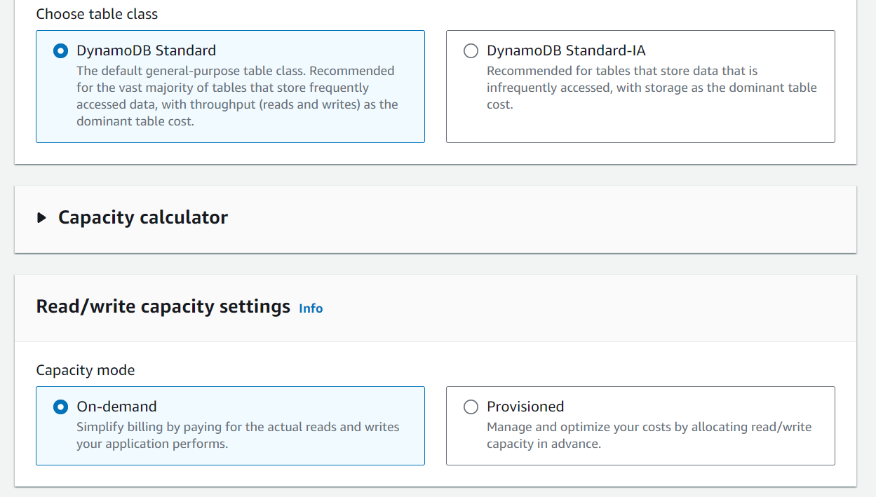

Once the table is created, customer data can be added. After selecting the table, the "Create item" button is clicked to add a new item (customer) to the table. Each item will have attributes (first name, last name, and email address).

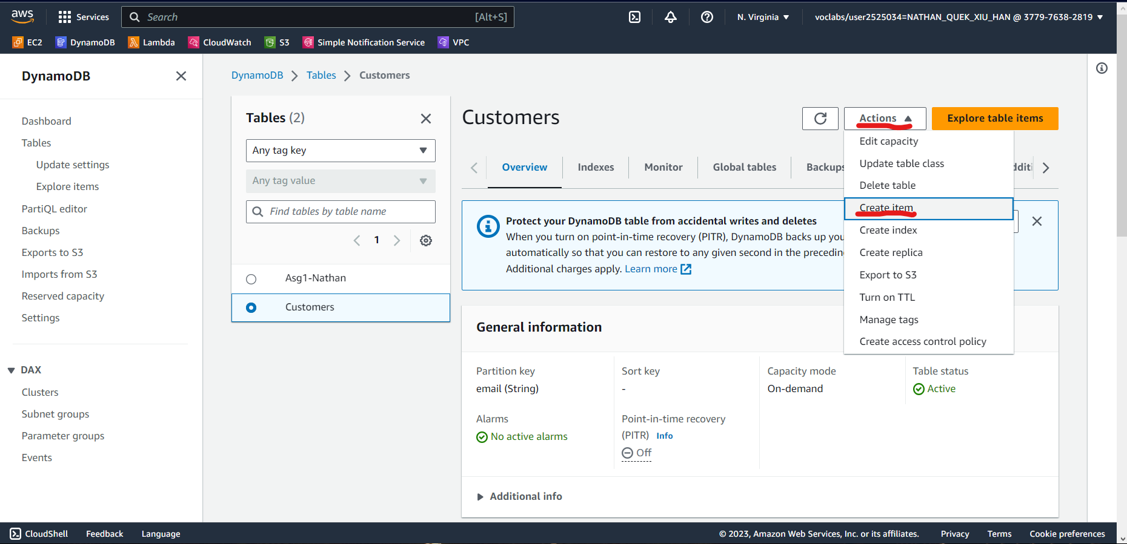

Attributes are added to each customer. New attributes can be added In the "Item details" section by clicking on the "+" button.

For this example, enter the following attributes below.

Attribute name: Enter "first_name."

Attribute type: Select "String" as the data type.

Value: Enter the customer's first name in the value field.

Similarly, add attributes for "last_name" and "email."

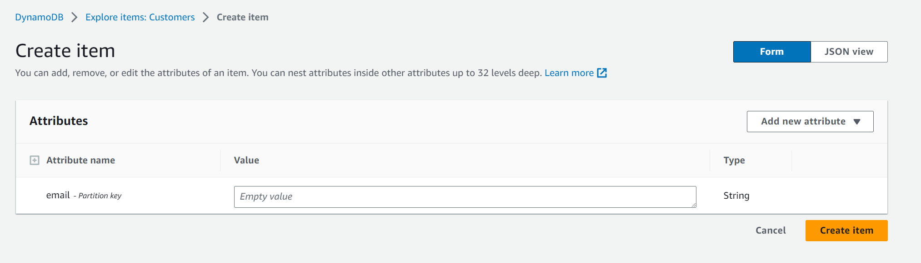

After adding all the attributes for the customer, it is saved to the table using the "Save" button.

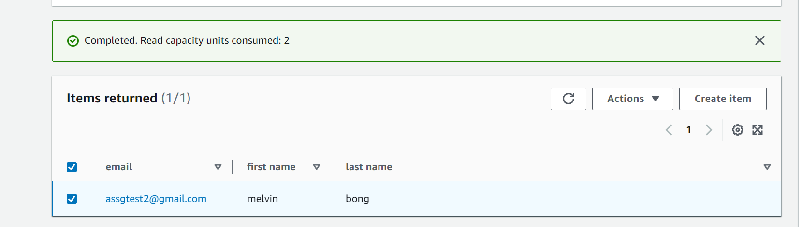

Customer data can be retrieved using the Primary Key (email) or other attributes. The "Get item" operation in DynamoDB can be used to retrieve a specific customer's data using their email. [Work in Progress]

## 4.5 HTML Forms Page

Navigate to Lambda function and click “Create Function”.

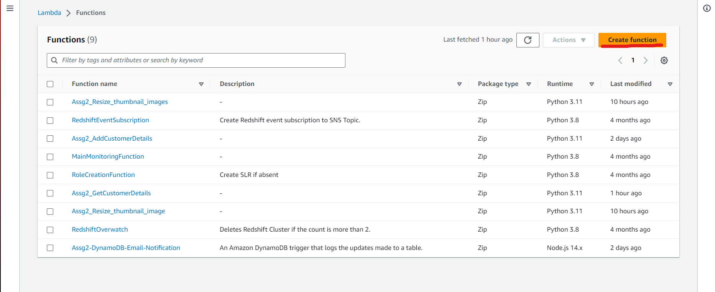

The function is named “Assg2_AddCustomerDetail” and Runtime is changed to “Python”. Click on Change default execution role to use the existing role “LabRole”. This step is repeated to create a second function, Assg2_GetCustomerDetails.

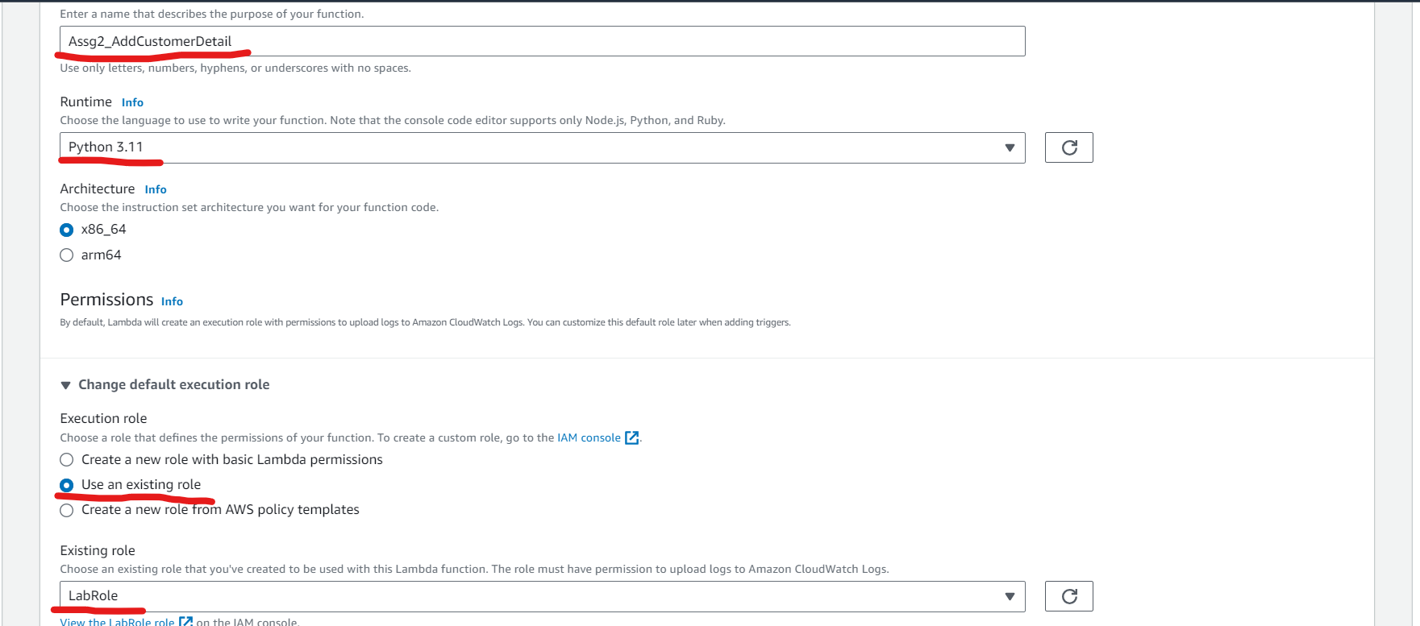

In Assg2_AddCustomerDetails, the original code in Code Source is replaced with the code below, tested, and deployed.

NOTE: Change the test JSON values to email, first name, and last name.

|  |
| --- |
| import json import boto3  dynamodb = boto3.client('dynamodb')  DYNAMODB_TABLE = 'Customers' # Replace with your actual table name  def lambda_handler(event, context):  print('Received event:', event)   email = event.get('email')  first_name = event.get('first name')  last_name = event.get('last name')   if email and first_name and last_name:  data = {  'email': email,  'firstName': first_name,  'lastName': last_name  }   # Store data in DynamoDB  store_data_in_dynamodb(data)   response = {  "statusCode": 200,  "headers": {  "Content-Type": "application/json",  "Access-Control-Allow-Origin": "*"  },  "isBase64Encoded": False,  "body": json.dumps({"result": "Success"})  }  else:  response = {  "statusCode": 400,  "headers": {  "Content-Type": "application/json",  "Access-Control-Allow-Origin": "*"  },  "isBase64Encoded": False,  "body": json.dumps({"error": "Missing required data"})  }   return response  def store_data_in_dynamodb(data):  params = {  'TableName': DYNAMODB_TABLE,  'Item': {  'email': {'S': data['email']},  'first name': {'S': data['firstName']},  'last name': {'S': data['lastName']}  }  }  dynamodb.put_item(**params) |

Repeat this for Assg2_GetCustomerDetails, but use the code provided below.

|  |
| --- |
| import json import boto3  dynamodb = boto3.client('dynamodb')  DYNAMODB_TABLE = 'Customers' # Replace with your actual table name  def lambda_handler(event, context):  print('Received event:', event)   email = event.get('email')  first_name = event.get('first name')  last_name = event.get('last name')   if email and first_name and last_name:  data = {  'email': email,  'firstName': first_name,  'lastName': last_name  }   # Store data in DynamoDB  store_data_in_dynamodb(data)   response = {  "statusCode": 200,  "headers": {  "Content-Type": "application/json",  "Access-Control-Allow-Origin": "*"  },  "isBase64Encoded": False,  "body": json.dumps({"result": "Success"})  }  else:  response = {  "statusCode": 400,  "headers": {  "Content-Type": "application/json",  "Access-Control-Allow-Origin": "*"  },  "isBase64Encoded": False,  "body": json.dumps({"error": "Missing required data"})  }   return response  def store_data_in_dynamodb(data):  params = {  'TableName': DYNAMODB_TABLE,  'Item': {  'email': {'S': data['email']},  'first name': {'S': data['firstName']},  'last name': {'S': data['lastName']}  }  }  dynamodb.put_item(**params) |

Navigate to API Gateway and click “Create API”.

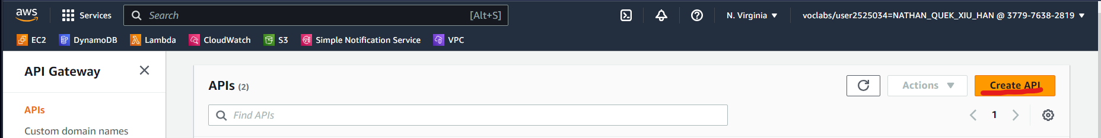

Scroll down to RestAPI and select “Build”. In the “Choose the protocol”, select “New API”, enter your API name and description, and create API.

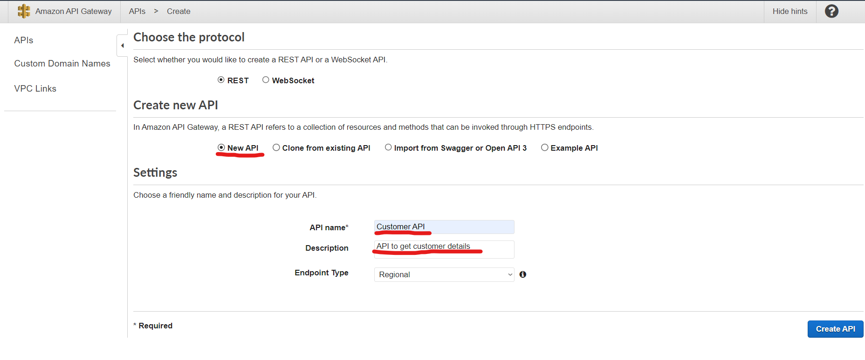

In the Resources page, click “Actions” and create new resources “addcustomerdetails” and tick “Enable API Gateway CORS”.

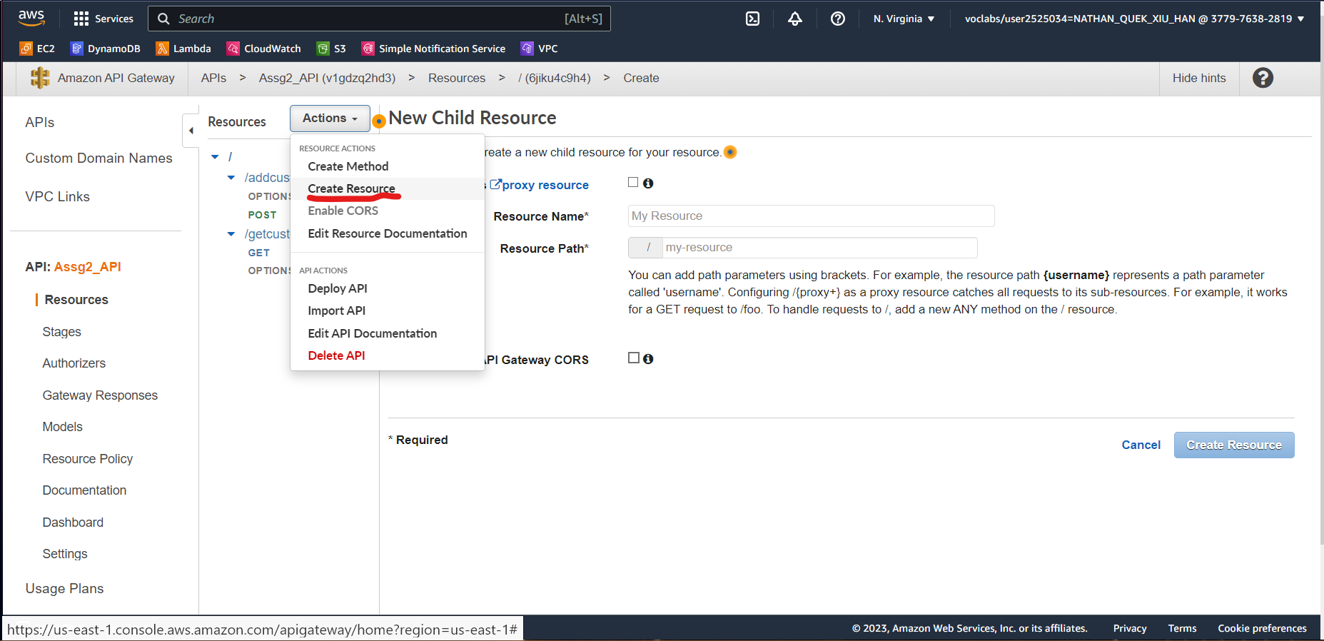

After the resource is created, click “Action” to create a method for POST. For integration type, use Lambda Function and select the lambda function created to add customer details.

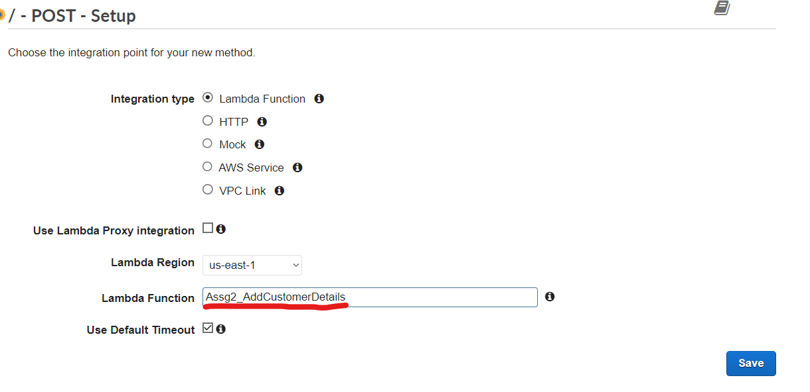

Repeat step 7 for “getcustomerdetails” resource and the “GET” method for the lambda function Assg2_GetCustomerDetails.

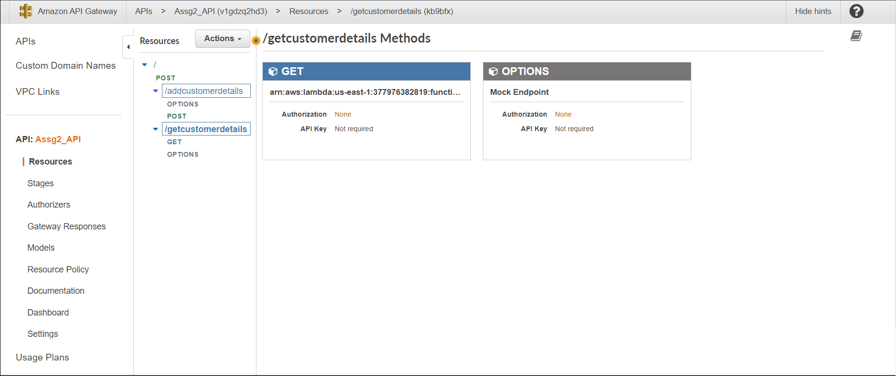

Click “/” resource Select “Actions” and click on Deploy API. Create a new deployment stage and enter the Stage name.

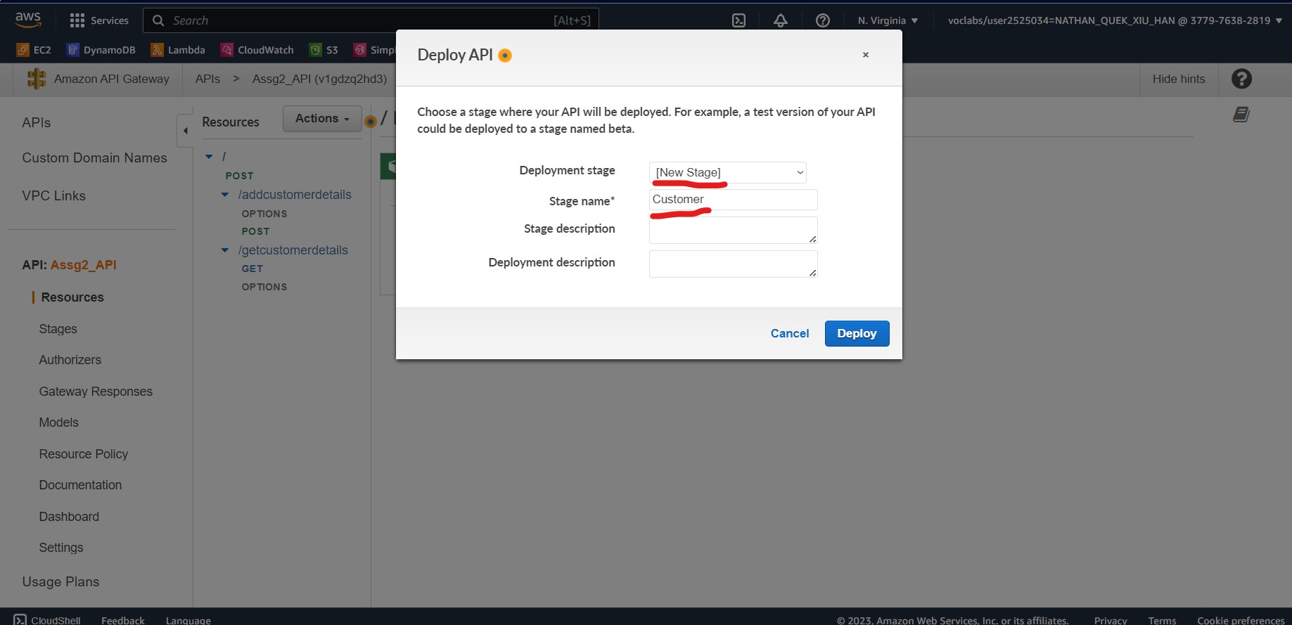

In Stages, click the Customer drop-down and click on the “POST” and “GET” methods to get the invoked URL. Copy this link into a notepad.

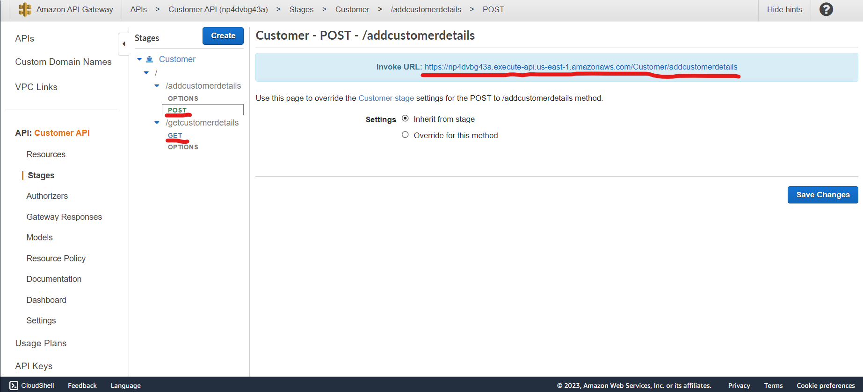

Navigate to the lambda function created from steps 1 to 4. Adding API Gateway as a trigger for both the lambda function.

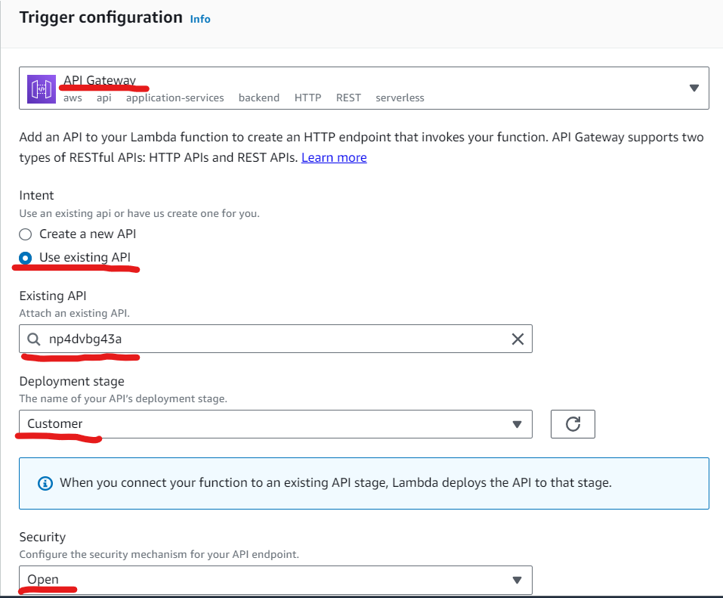

Create the HTML using Visual Studio Code and use the code provided. Changing the POST and GET URL to the invoked URL from step 11.

|  |
| --- |
| <!DOCTYPE html> <**html** lang="en"> <**head**>  <**meta** charset="UTF-8">  <**meta** name="viewport" content="width=device-width, initial-scale=1.0">  <**title**>Customer Form</**title**>  <**meta** charset="utf-8">  <**meta** name="viewport" content="width=device-width, initial-scale=1, shrink-to-fit=no">   <**link** rel="stylesheet" href="https://stackpath.bootstrapcdn.com/bootstrap/4.3.1/css/bootstrap.min.css" integrity="sha384-ggOyR0iXCbMQv3Xipma34MD+dH/1fQ784/j6cY/iJTQUOhcWr7x9JvoRxT2MZw1T" crossorigin="anonymous">  <**script** src="https://code.jquery.com/jquery-3.3.1.slim.min.js" integrity="sha384-q8i/X+965DzO0rT7abK41JStQIAqVgRVzpbzo5smXKp4YfRvH+8abtTE1Pi6jizo" crossorigin="anonymous"></**script**>  <**script** src="https://cdnjs.cloudflare.com/ajax/libs/popper.js/1.14.7/umd/popper.min.js" integrity="sha384-UO2eT0CpHqdSJQ6hJty5KVphtPhzWj9WO1clHTMGa3JDZwrnQq4sF86dIHNDz0W1" crossorigin="anonymous"></**script**>  <**script** src="https://stackpath.bootstrapcdn.com/bootstrap/4.3.1/js/bootstrap.min.js" integrity="sha384-JjSmVgyd0p3pXB1rRibZUAYoIIy6OrQ6VrjIEaFf/nJGzIxFDsf4x0xIM+B07jRM" crossorigin="anonymous"></**script**>  <**script** src="https://ajax.googleapis.com/ajax/libs/jquery/3.3.1/jquery.min.js"></**script**> </**head**> <**body**>   <**form** id="customerForm">  <**div** class="container">  <**div** class="row justify-content-center mt-3">  <**div** class="col-md-6">  <**h1**>Add Customer Details</**h1**>  <**p**>Enter your information below to store your customer data into the database.</**p**>  <**p**>We don't share your contact information with anyone else.</**p**>  </**div**>  </**div**>  <**div** class="row justify-content-center">  <**div** class="col-md-6">  <**div** class="form-group">  <**label** for="email" class="font-weight-bold">Email</**label**>  <**input** type="email" class="form-control" id="email-input" placeholder="Your email address" required>  </**div**>  <**div** class="form-group">  <**label** for="firstName" class="font-weight-bold">First Name</**label**>  <**input** type="text" class="form-control" id="firstName-input" placeholder="Your first name" required>  </**div**>  <**div** class="form-group">  <**label** for="lastName" class="font-weight-bold">Last Name</**label**>  <**input** type="text" class="form-control" id="lastName-input" placeholder="Your last name" required>  </**div**>  <**div** id="form-response"></**div**>  <**button** type="button" onClick="submitToAPI(event)" class="btn btn-primary btn-block mt-3" style="margin-top:20px;">Submit</**button**>  </**div**>  </**div**>  </**div**>  </**form**>   <**div** class="container mt-5">  <**div** class="row justify-content-center">  <**div** class="col-md-8">  <**h2**>Customer Details</**h2**>  <**table** class="table">  <**thead**>  <**tr**>  <**th** scope="col">First Name</**th**>  <**th** scope="col">Last Name</**th**>  <**th** scope="col">Email</**th**>  </**tr**>  </**thead**>  <**tbody** id="customerTableBody">  <!-- Customer details will be added here using JavaScript -->  </**tbody**>  </**table**>  </**div**>  </**div**>  </**div**>   <**script**>  function submitToAPI(e) {  e.preventDefault();   var reEmail = /^([\w-\.]+@([\w-]+\.)+[\w-]{2,6})?$/;  var firstNameRegex = /[A-Za-z]{1}[A-Za-z]/;  var lastNameRegex = /[A-Za-z]{1}[A-Za-z]/;   var email = $("#email-input").val();  var firstName = $("#firstName-input").val();  var lastName = $("#lastName-input").val();   if (!reEmail.test(email)) {  alert("Please enter a valid email address");  return;  }   if (!firstNameRegex.test(firstName)) {  alert("Name cannot be less than 2 characters");  return;  }   if (!lastNameRegex.test(lastName)) {  alert("Name cannot be less than 2 characters");  return;  }   var data = {  email: email,  'first name': firstName,  'last name': lastName,  };   $.ajax({  type: "POST",  url: "https://v1gdzq2hd3.execute-api.us-east-1.amazonaws.com/Customer/addcustomerdetails",  dataType: "json",  contentType: "application/json; charset=utf-8",  data: JSON.stringify(data),  success: function () {  // Clear the form and show a success message  alert("Successfully added customer details!");  document.getElementById("customerForm").reset();  location.reload();  },  error: function () {  // Show an error message  alert("Unsuccessful.");  }  });  }   function fetchAndDisplayRecords() {  $.ajax({  type: "GET",  url: "https://v1gdzq2hd3.execute-api.us-east-1.amazonaws.com/Customer/getcustomerdetails",  dataType: "json",  success: function (response) {  var tableBody = $("#customerTableBody");  tableBody.empty(); // Clear previous records   if (response && response.length > 0) {  response.forEach(function (record) {  var rowHtml = `  <tr>  <td>${record['first name']}</td>  <td>${record['last name']}</td>  <td>${record['email']}</td>  </tr>`;  tableBody.append(rowHtml);  });  } else {  tableBody.html(`<tr><td colspan="3">No customer records found.</td></tr>`);  }  },  error: function () {  alert("Failed to fetch customer records.");  }  });  }  // Call fetchAndDisplayRecords when the page loads to show existing records  $(document).ready(function () {  fetchAndDisplayRecords();  });  </**script**> </**body**> </**html**> |

Navigate to the S3 bucket and select assg2-bucket. Click on “Upload” to upload the html file into the S3 bucket.

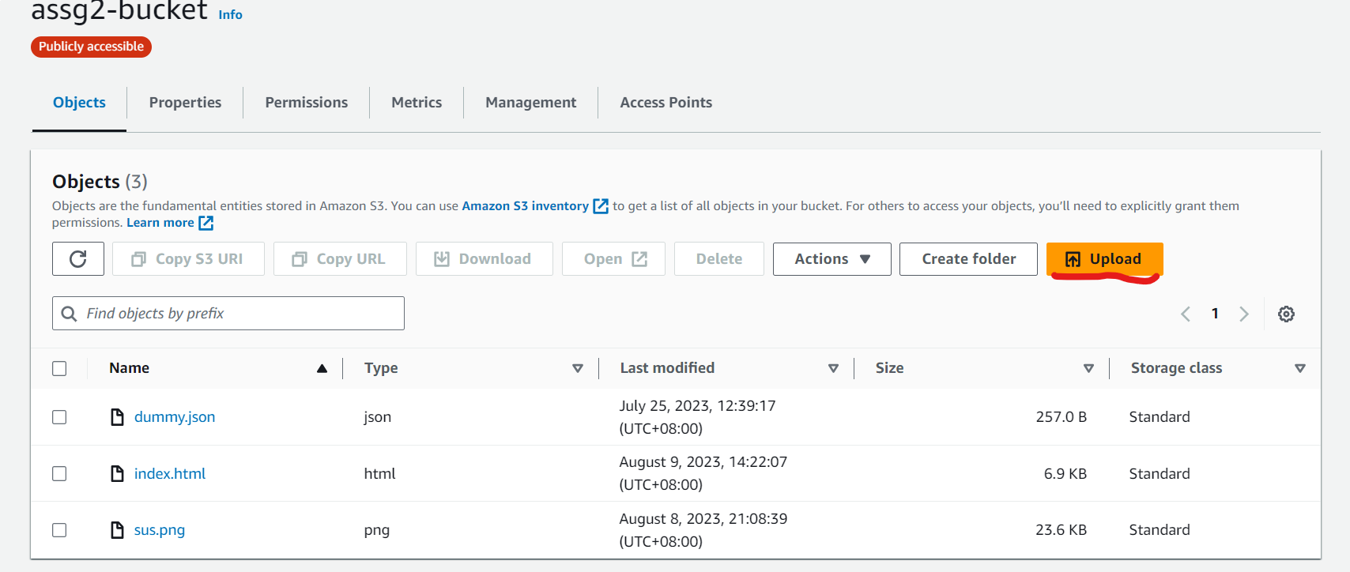

Click on Properties and scroll down to “Static website hosting” and click Edit.



Select enable for “Static website hosting” and input “index.html” as Index document, “error.html” as Error document and click “Save changes”.

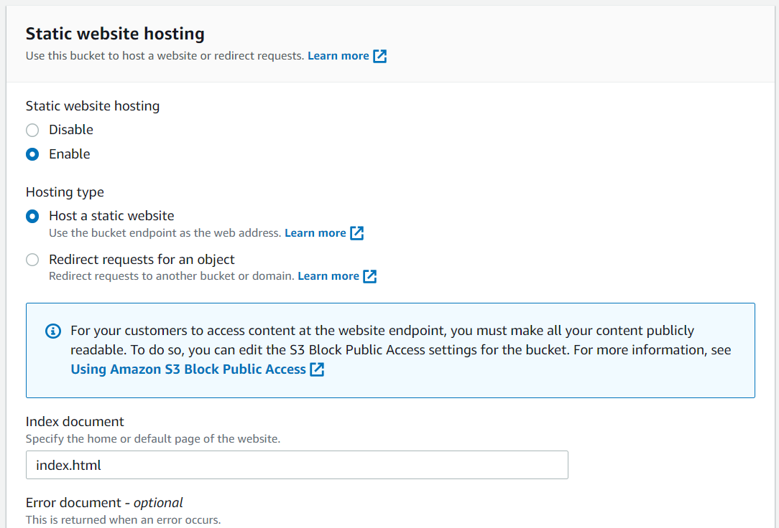

## 4.6 DynamoDB and S3 Notification

### 4.6.1 DynamoDB

To create an email notification whenever new customer data is added to DynamoDB, a Lambda function must be created.

On the Lambda page, create a new function.

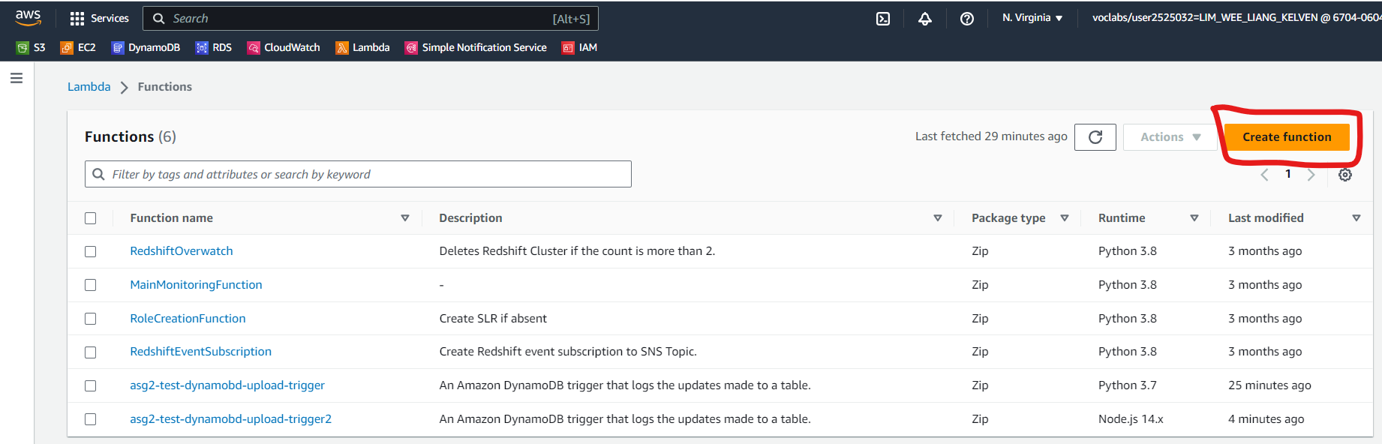

Select “**Use a Blueprint**”. Select “Process updates made to a DDB table” in **nodejs 14.x**. Name the function “Assg2-DynamoDB-Email-Notification”.

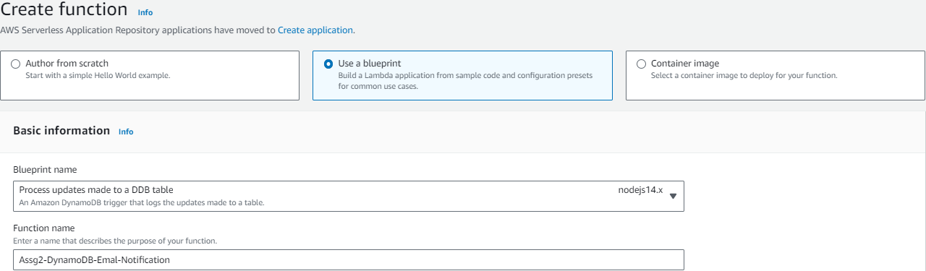

For the Execution role, select “LabRole” for Use an existing role.

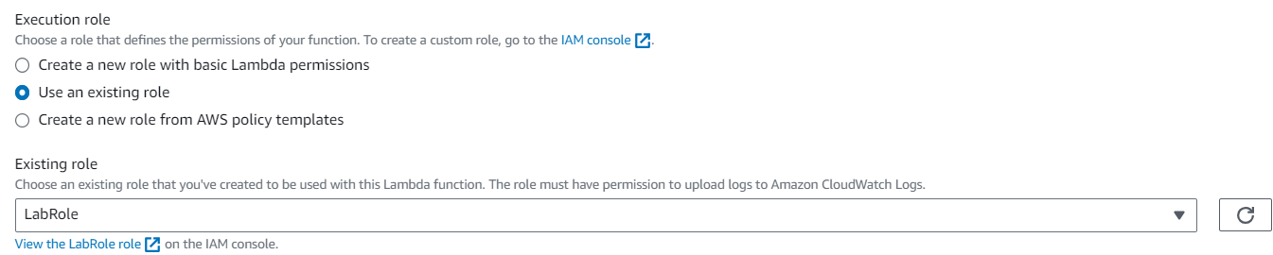

For the DynamoDB trigger, select Customers database. Select 1 for Batch Size and create the function.

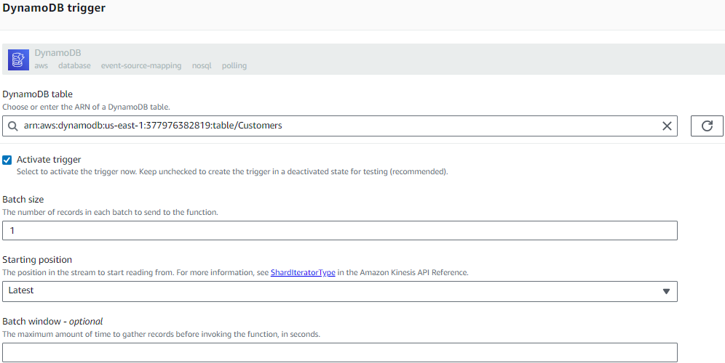

Under the Code tab, in Code source, enter the following code and click on Deploy.

|  |
| --- |
| const AWS = require("aws-sdk");  const sns = new AWS.SNS();   exports.handler = async (event) => {  await sns.publish({  "Message": "New Item added" + JSON.stringify(event.Records[0].dynamodb.NewImage), // Edit message if needed  "TopicArn": "arn:aws:sns:us-east-1:670406042058:asg2-nosql-db-test" // Replace Topic ARN with yours  }).promise();  }; |

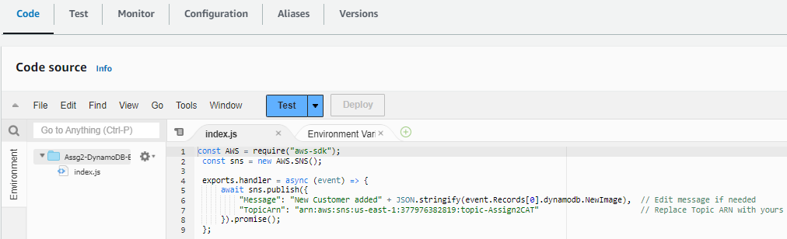

### 4.6.2 S3 bucket

To create an email notification whenever a file is added to an S3 bucket, an event notification must be created.

Edit the “topic-Assign2CAT” topic.

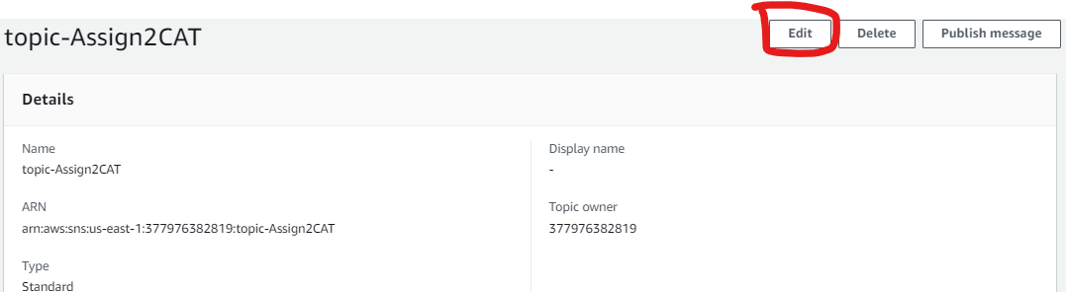

Under **Access policy – optional**, copy-paste this code in.

|  |
| --- |
| {  "Version": "2012-10-17",  "Id": "example-ID",  "Statement": [  {  "Sid": "Example SNS topic policy",  "Effect": "Allow",  "Principal": {  "Service": "s3.amazonaws.com"  },  "Action": [  "SNS:Publish"  ],  "Resource": "Replace with your SNS-topic-ARN",  "Condition": {  "ArnLike": {  "aws:SourceArn": "Replace with your bucket ARN"  },  "StringEquals": {  "aws:SourceAccount": Replace with your 12-digit account id"  }  }  }  ] } |

Paste your topic ARN for “Resource”, your bucket ARN for “aws:SourceARN”, and your 12-digit account ID for “aws:SourceAccount”. Save your changes. 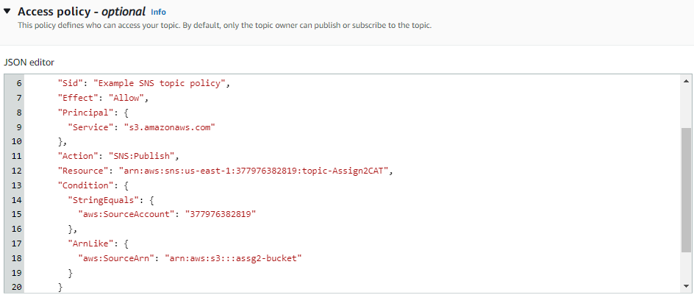

In the assg2-bucket bucket, go to Properties 🡪 Event notifications 🡪 Create event notification.

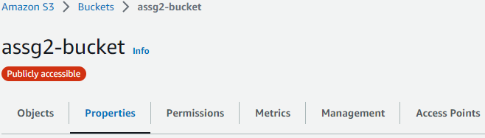

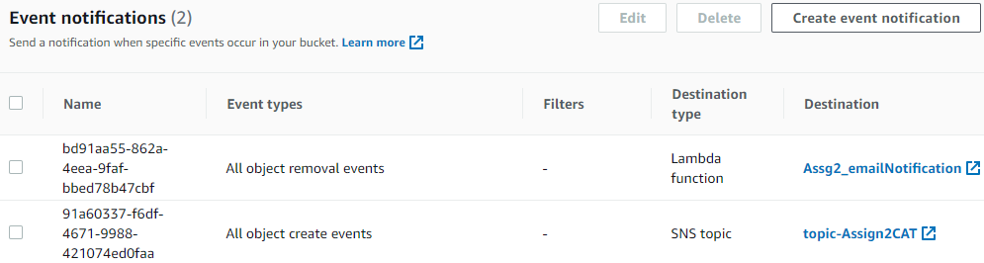

Name the event “Assg2-S3-Email-Notification”.

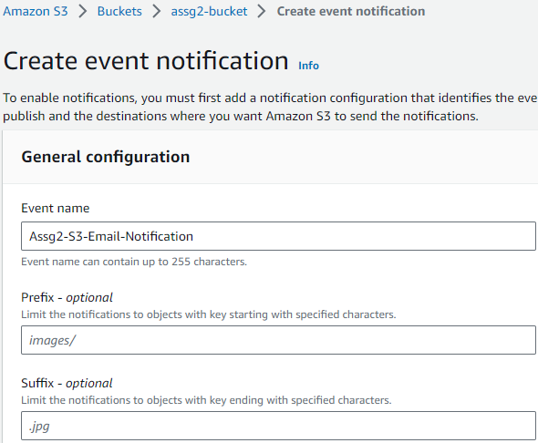

Select “All object create events”

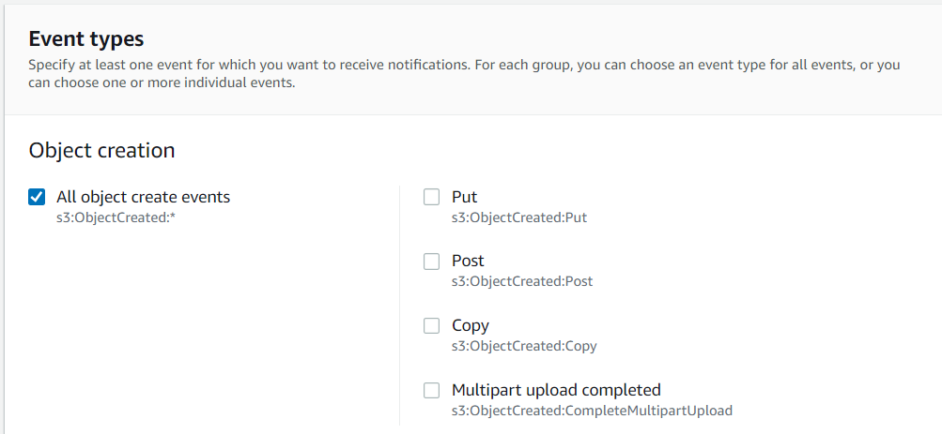

Under Destination, choose “SNS topic” and select the topic-Assign2Cat topic.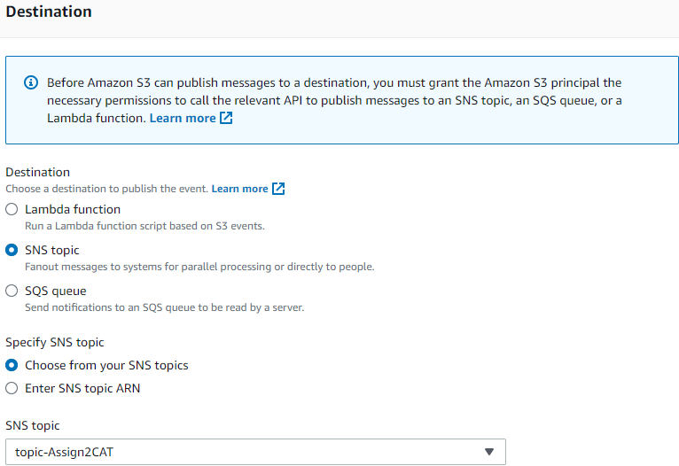

# **5.0 Code Used for Lambda Functions and HTML Page**

## 5.1 Assg2_AddCustomerDetails

|  |
| --- |
| import json import boto3  dynamodb = boto3.client('dynamodb')  DYNAMODB_TABLE = 'Customers' # Replace with your actual table name  def lambda_handler(event, context):  print('Received event:', event)   email = event.get('email')  first_name = event.get('first name')  last_name = event.get('last name')   if email and first_name and last_name:  data = {  'email': email,  'firstName': first_name,  'lastName': last_name  }   # Store data in DynamoDB  store_data_in_dynamodb(data)   response = {  "statusCode": 200,  "headers": {  "Content-Type": "application/json",  "Access-Control-Allow-Origin": "*"  },  "isBase64Encoded": False,  "body": json.dumps({"result": "Success"})  }  else:  response = {  "statusCode": 400,  "headers": {  "Content-Type": "application/json",  "Access-Control-Allow-Origin": "*"  },  "isBase64Encoded": False,  "body": json.dumps({"error": "Missing required data"})  }   return response  def store_data_in_dynamodb(data):  params = {  'TableName': DYNAMODB_TABLE,  'Item': {  'email': {'S': data['email']},  'first name': {'S': data['firstName']},  'last name': {'S': data['lastName']}  }  }  dynamodb.put_item(**params) |

## 5.2 Assg2_GetCustomerDetails

|  |
| --- |
| import json import boto3  dynamodb = boto3.client('dynamodb')  DYNAMODB_TABLE = 'Customers' # Replace with your actual table name  def lambda_handler(event, context):  print('Received event:', event)   email = event.get('email')  first_name = event.get('first name')  last_name = event.get('last name')   if email and first_name and last_name:  data = {  'email': email,  'firstName': first_name,  'lastName': last_name  }   # Store data in DynamoDB  store_data_in_dynamodb(data)   response = {  "statusCode": 200,  "headers": {  "Content-Type": "application/json",  "Access-Control-Allow-Origin": "*"  },  "isBase64Encoded": False,  "body": json.dumps({"result": "Success"})  }  else:  response = {  "statusCode": 400,  "headers": {  "Content-Type": "application/json",  "Access-Control-Allow-Origin": "*"  },  "isBase64Encoded": False,  "body": json.dumps({"error": "Missing required data"})  }   return response  def store_data_in_dynamodb(data):  params = {  'TableName': DYNAMODB_TABLE,  'Item': {  'email': {'S': data['email']},  'first name': {'S': data['firstName']},  'last name': {'S': data['lastName']}  }  }  dynamodb.put_item(**params) |

## 5.3 HTML Page

|  |
| --- |
| <!DOCTYPE html> <**html** lang="en"> <**head**>  <**meta** charset="UTF-8">  <**meta** name="viewport" content="width=device-width, initial-scale=1.0">  <**title**>Customer Form</**title**>  <**meta** charset="utf-8">  <**meta** name="viewport" content="width=device-width, initial-scale=1, shrink-to-fit=no">   <**link** rel="stylesheet" href="https://stackpath.bootstrapcdn.com/bootstrap/4.3.1/css/bootstrap.min.css" integrity="sha384-ggOyR0iXCbMQv3Xipma34MD+dH/1fQ784/j6cY/iJTQUOhcWr7x9JvoRxT2MZw1T" crossorigin="anonymous">  <**script** src="https://code.jquery.com/jquery-3.3.1.slim.min.js" integrity="sha384-q8i/X+965DzO0rT7abK41JStQIAqVgRVzpbzo5smXKp4YfRvH+8abtTE1Pi6jizo" crossorigin="anonymous"></**script**>  <**script** src="https://cdnjs.cloudflare.com/ajax/libs/popper.js/1.14.7/umd/popper.min.js" integrity="sha384-UO2eT0CpHqdSJQ6hJty5KVphtPhzWj9WO1clHTMGa3JDZwrnQq4sF86dIHNDz0W1" crossorigin="anonymous"></**script**>  <**script** src="https://stackpath.bootstrapcdn.com/bootstrap/4.3.1/js/bootstrap.min.js" integrity="sha384-JjSmVgyd0p3pXB1rRibZUAYoIIy6OrQ6VrjIEaFf/nJGzIxFDsf4x0xIM+B07jRM" crossorigin="anonymous"></**script**>  <**script** src="https://ajax.googleapis.com/ajax/libs/jquery/3.3.1/jquery.min.js"></**script**> </**head**> <**body**>   <**form** id="customerForm">  <**div** class="container">  <**div** class="row justify-content-center mt-3">  <**div** class="col-md-6">  <**h1**>Add Customer Details</**h1**>  <**p**>Enter your information below to store your customer data into the database.</**p**>  <**p**>We don't share your contact information with anyone else.</**p**>  </**div**>  </**div**>  <**div** class="row justify-content-center">  <**div** class="col-md-6">  <**div** class="form-group">  <**label** for="email" class="font-weight-bold">Email</**label**>  <**input** type="email" class="form-control" id="email-input" placeholder="Your email address" required>  </**div**>  <**div** class="form-group">  <**label** for="firstName" class="font-weight-bold">First Name</**label**>  <**input** type="text" class="form-control" id="firstName-input" placeholder="Your first name" required>  </**div**>  <**div** class="form-group">  <**label** for="lastName" class="font-weight-bold">Last Name</**label**>  <**input** type="text" class="form-control" id="lastName-input" placeholder="Your last name" required>  </**div**>  <**div** id="form-response"></**div**>  <**button** type="button" onClick="submitToAPI(event)" class="btn btn-primary btn-block mt-3" style="margin-top:20px;">Submit</**button**>  </**div**>  </**div**>  </**div**>  </**form**>   <**div** class="container mt-5">  <**div** class="row justify-content-center">  <**div** class="col-md-8">  <**h2**>Customer Details</**h2**>  <**table** class="table">  <**thead**>  <**tr**>  <**th** scope="col">First Name</**th**>  <**th** scope="col">Last Name</**th**>  <**th** scope="col">Email</**th**>  </**tr**>  </**thead**>  <**tbody** id="customerTableBody">  <!-- Customer details will be added here using JavaScript -->  </**tbody**>  </**table**>  </**div**>  </**div**>  </**div**>   <**script**>  function submitToAPI(e) {  e.preventDefault();   var reEmail = /^([\w-\.]+@([\w-]+\.)+[\w-]{2,6})?$/;  var firstNameRegex = /[A-Za-z]{1}[A-Za-z]/;  var lastNameRegex = /[A-Za-z]{1}[A-Za-z]/;   var email = $("#email-input").val();  var firstName = $("#firstName-input").val();  var lastName = $("#lastName-input").val();   if (!reEmail.test(email)) {  alert("Please enter a valid email address");  return;  }   if (!firstNameRegex.test(firstName)) {  alert("Name cannot be less than 2 characters");  return;  }   if (!lastNameRegex.test(lastName)) {  alert("Name cannot be less than 2 characters");  return;  }   var data = {  email: email,  'first name': firstName,  'last name': lastName,  };   $.ajax({  type: "POST",  url: "https://v1gdzq2hd3.execute-api.us-east-1.amazonaws.com/Customer/addcustomerdetails",  dataType: "json",  contentType: "application/json; charset=utf-8",  data: JSON.stringify(data),  success: function () {  // Clear the form and show a success message  alert("Successfully added customer details!");  document.getElementById("customerForm").reset();  location.reload();  },  error: function () {  // Show an error message  alert("Unsuccessful.");  }  });  }   function fetchAndDisplayRecords() {  $.ajax({  type: "GET",  url: "https://v1gdzq2hd3.execute-api.us-east-1.amazonaws.com/Customer/getcustomerdetails",  dataType: "json",  success: function (response) {  var tableBody = $("#customerTableBody");  tableBody.empty(); // Clear previous records   if (response && response.length > 0) {  response.forEach(function (record) {  var rowHtml = `  <tr>  <td>${record['first name']}</td>  <td>${record['last name']}</td>  <td>${record['email']}</td>  </tr>`;  tableBody.append(rowHtml);  });  } else {  tableBody.html(`<tr><td colspan="3">No customer records found.</td></tr>`);  }  },  error: function () {  alert("Failed to fetch customer records.");  }  });  }  // Call fetchAndDisplayRecords when the page loads to show existing records  $(document).ready(function () {  fetchAndDisplayRecords();  });  </**script**> </**body**> </**html**> |

## 5.4 DynamoDB Notification

|  |
| --- |
| const AWS = require("aws-sdk"); const sns = new AWS.SNS();  exports.handler = async (event) => {  await sns.publish({  "Message": "New Item added" + JSON.stringify(event.Records[0].dynamodb.NewImage), // Edit message if needed  "TopicArn": "arn:aws:sns:us-east-1:670406042058:asg2-nosql-db-test" // Replace Topic ARN with yours  }).promise();  }; |

# **6.0 Testing Methods & Results**

## 6.1 VPC and Auto-Scaler

To show the auto-scaler working, I will use heavyload on the RDC to prove that when CPU utilisation reaches 60% it auto-scales to meet the demand creating more EC2 instances. The recording also shows the EC2 instance website working where you could view the employees and add new employees. It also shows the EC2 instances scaling in when the CPU utilisation dropped below 60%.

For video purposes, the instance warmup was set to 0 seconds, but it will be changed back to 300 seconds. The auto-scaler will also suspend the launch to prevent credits from being drained.

[Demo YouTube video of auto scalers scaling in and scaling out, EC2 website working using the public IPV4 where the employee list was used](https://youtu.be/puhkR1LQwXs)

At 8 min it scales out, and at 39 mins it scales in.

## 6.2 Load Balancer

*Load balancer attached to the public subnets across the 2 AZ in the correct VPC*

## 6.3 DynamoDB

Creating a table with Customers as its name to store customer data.





It would then prompt the user to add in attributes such as email (as shown) and additionally adding of first name and last name for the requirement of the project.



After clicking “create table” the completed screen will be shown. Indicating that the DynamoDB is created.

## 6.4 HTML Forms Page

Navigate to S3 assg2-bucket properties, scroll down to the “Static website hosting” and click on the URL to test the HTML. Enter the email, First Name and Last Name and submit the form.

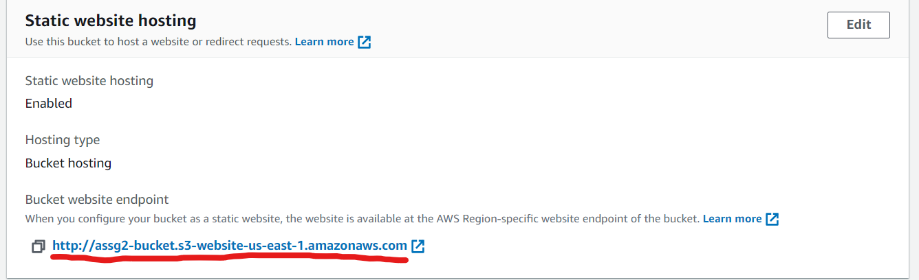

A pop-up will show after submitting the customer details indicating the submission is done.

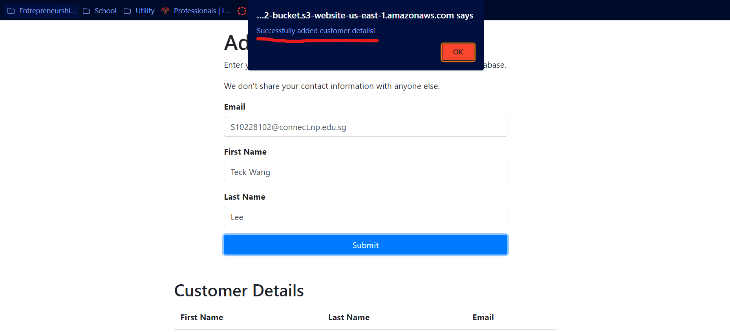

## 6.5 DynamoDB Notification

After adding a customer through the HTML form, an email notification will be sent to indicate a successfully upload into the DynamoDB.

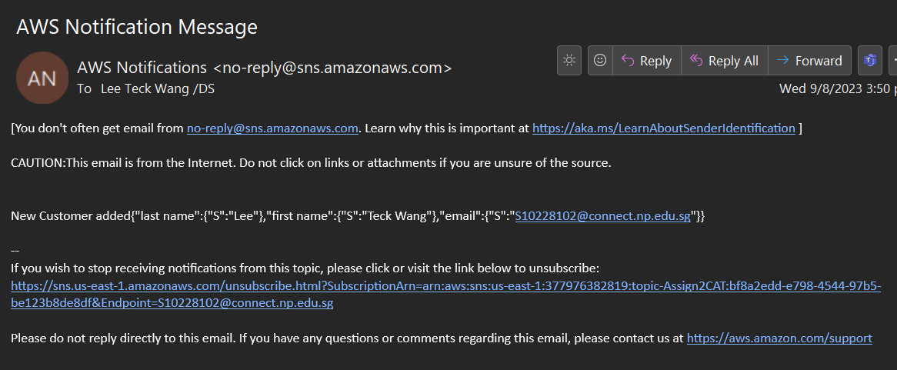

## 6.6 S3 Notification

To test whether the S3 notification works, an image file can be uploaded into the bucket.

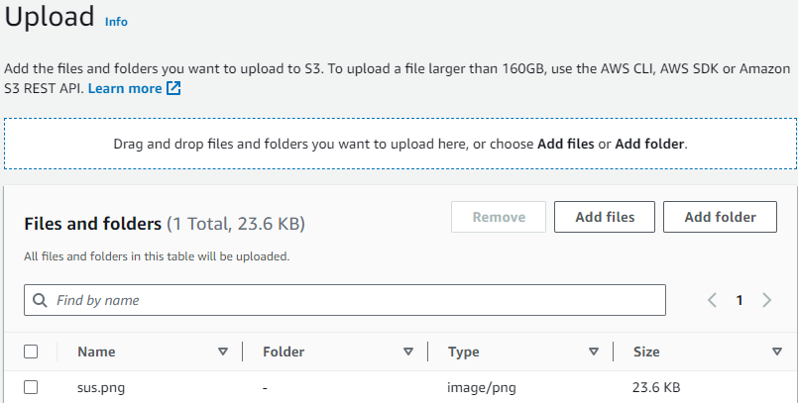

After waiting for a few seconds, an email notification is received as shown below for both adding an image into the S3 Bucket and DynamoDB.

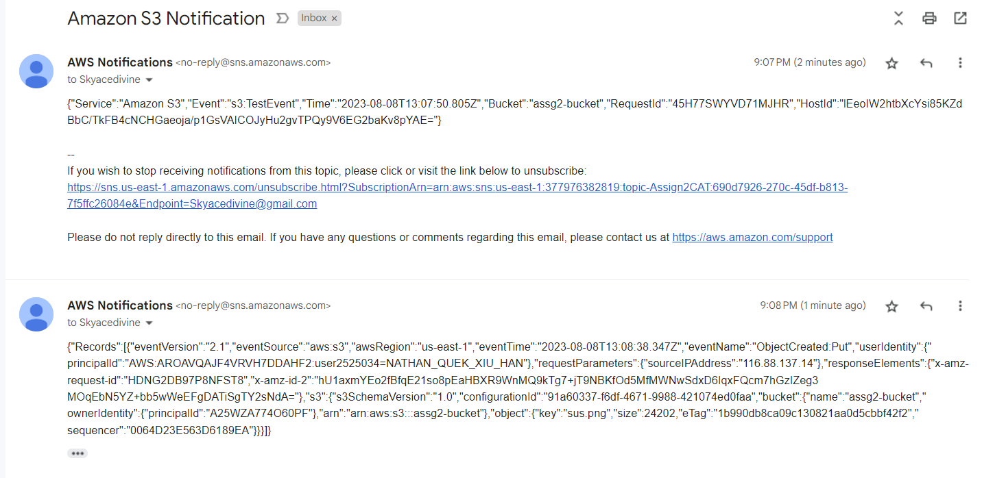

# **7.0 Explanation of Cloud Solution according to Design Principles**

## 7.1 Security

In accordance with the well-architected framework, to ensure the solution is safe and secure, various forms of security were implemented in all layers of the AWS system so that it will be secure at every level. Examples of how we handled them are by allotting two availability zones for our VPC with load balancers, security groups, and EC2 instances.

AWS IAM was also used which enables transparency within the organisation and user accountability. User actions are logged and monitored so measures are in place if an anomaly is detected. Likewise, the principle of least privilege was enforced to only give privilege when required.

Our solution is secure because of the following system that was implemented:

* VPC (Virtual Private Cloud): Ensures that your resources are in a private, isolated section of the AWS Cloud. With proper configurations, you can enhance security by using security groups and network ACLs.
* EC2: Instance roles and security groups should be used to provide fine-grained access to resources and ensure that only necessary ports are open.
* Load Balancer: Application Load Balancer (ALB) can be integrated with AWS WAF (Web Application Firewall) for enhanced security against web exploits.
* CloudWatch & SNS for DynamoDB and S3: By setting up alarms for suspicious activities, you ensure real-time security monitoring and notifications.
* DynamoDB: Fine-grained access control can be set up with IAM to secure data. Encryption at rest is available.
* S3 Buckets: Ensure buckets are private by default, use bucket policies, and enable server-side encryption.

## 7.2 Reliability

Reliability refers to the ability of the infrastructure or service to recover from failure. The best way to recover from infrastructure failure is to prevent it from happening in the first place. To mitigate failures and downtime required to recover from failure, the following systems were used.

* Auto-Scaling: This helps in maintaining application availability and allows you to automatically add or remove EC2 instances according to conditions you define which allows us to scale horizontally.
* Load Balancer: Distributes incoming traffic across multiple targets, enhancing the availability and fault tolerance of your application which prevents us from guessing the capacity needed for each system and serves as a level of automation.
* DynamoDB: Built for high availability and backups, with cross-region replication and point-in-time recovery.
* S3 Bucket: Provides 99.9% data storage durability over a given year and versioning can be used to recover from both unintended user actions and application failures.

## 7.3 Performance Efficiency

Performance efficiency refers to the ability to use computing resources eﬃciently to meet system requirements and to maintain that eﬃciency against changing demand and technologies. AWS is efficient as it does not require users to run and maintain any physical server.

* EC2 Configuration: Choosing the right type of instance (memory-optimised, compute-optimised, etc.) enhances performance. Use the latest generation of instances.
* Auto-Scaler: Dynamically scaling resources ensures that you're meeting the demand without over-provisioning.
* Load Balancer: Helps in efficiently distributing incoming traffic for optimal resource utilisation.
* DynamoDB: Supports auto-scaling of read and write capacities to adjust to actual traffic patterns.

## 7.4 Cost Optimisation

Cost optimisation in AWS involves smartly managing and allocating resources to ensure efficient operations without overspending. By leveraging features like Auto-Scaling, choosing the right EC2 instance types, implementing S3 lifecycle policies, and tailoring DynamoDB pricing models, one can significantly reduce costs while maintaining performance.

* Auto-Scaling: You pay only for the EC2 instances you need. This means during low traffic, fewer instances run, saving cost.
* EC2: Use reserved instances or spot instances based on only used cases to save costs.
* S3 Buckets: Use object lifecycle policies to move older data to cheaper storage classes or delete them.
* DynamoDB: Use on-demand pricing or provisioned read/write capacity depending on your workload to manage costs.
* CloudWatch: Be selective in the metrics and logs you store to avoid unnecessary costs.

7.5 Overall Operation Excellence (Additional)

Operational excellence in AWS entails proactive monitoring, regular updates, and responsive actions to changes. Tools like CloudWatchMonitor offer insights into system performance, while practices such as updating HTML forms and utilising SNS notifications ensure the system remains robust, user-centric, and reactive to potential issues.

* CloudWatchMonitor: provides system-wide performance, set alarms, and react to changes in your AWS resources.
* HTML forms page: Regularly review and update this based on user feedback and error logs to ensure smooth operations.
* SNS notifications: These can be used not just for security but for any operational issues that arise in your AWS resources.

# **8.0 Explanation of Cloud Monitoring Plan for Web Application**

Explanation of your cloud monitoring plan for the web application and other AWS resources/services. Include the techniques and principles used in cloud monitoring.

Monitoring a cloud infrastructure is crucial to ensure optimal performance, security, and availability of applications and resources. For our web application and associated AWS resources and services, we've devised a comprehensive cloud monitoring plan. This plan is grounded on key principles and techniques that reflect best practices in cloud monitoring.

## 8.1 Objectives of Cloud Monitoring

Performance optimisation:

* To ensure the web application runs without an issue, identify any performance bottlenecks.

Cost management:

* Monitor how AWS resources are used to control expenses and to limit the resources used to ensure effective usage of cloud storage.

Security Monitoring:

* Detects and highlights potential security threats and vulnerabilities.

Availability:

* Ensures the web application and resources are always accessible with backups when natural events occur and functioning all the tools and functions are working whenever needed.

## 8.2 Techniques and Tools

CloudWatch will be the primary monitoring tool as it provides detailed visibility into resource utilisation, operational performance, and overall demand patterns.

Elements within CloudWatch:

* Metrics: Monitor common measurements like CPU usage, latency, and request counts.
* Alarms: Set up alert systems for irregular and outliers within observable activity or thresholds will allow the users to make timely decisions and ensure the maintenance of cloud integrity.
* Logs: Capture and analyse logs for troubleshooting and keeping track of web application activity.

Other Tools useful for cloud monitoring:

AWS Trusted Advisor:

* Purpose: Assesses AWS environment against best practices to optimise resources and bolster security.
* Security Insights: Identifies vulnerabilities such as open S3 buckets or overly permissive security group rules.
* Optimisation Recommendations: Offers advice on cost savings, improved performance, and efficient resource use.
* Real-time Analysis: Continuously scans AWS assets, highlighting immediate areas of concern.
* Detailed Reporting: Provides actionable insights for each recommendation.
* Notifications: Sends alerts for pressing issues, ensuring timely interventions.
* Fault Tolerance & Service Limits: Reviews for potential system breakdowns and checks usage against set service limits.

AWS X-Ray:

* Function: Distributed tracing service for visual application analysis.
* Debugging & Optimisation: Simplifies identification and resolution of application issues.
* Request Capture: Traces the full lifecycle of requests, from start to finish.
* Detailed Insights: Offers visibility into Latency bottlenecks, External API call paths and Database queries.
* X-Ray SDK: Key component for data collection, integrates directly into applications.
* Service Map: Visual representation of component interactions and request paths.
* Proactive Problem Solving: Enables developers to identify and rectify performance bottlenecks and anomalies.

# **9.0 References**

Amazon Web Service. (n.d.). *Walkthrough: Configuring a bucket for notifications (SNS topic or SQS queue) - Amazon Simple Storage Service*. AWS Documentation. Retrieved August 9, 2023, from https://docs.aws.amazon.com/AmazonS3/latest/userguide/ways-to-add-notification-config-to-bucket.html

Asija, A. (2022, November 24). *How To: S3 SNS Event Notifications (2 Min) | AWS | Email Alerts For S3 Bucket/Object Uploads*. YouTube. https://www.youtube.com/watch?v=bDBX5rAt3eQ&list=WL&index=4&ab_channel=GokceDB

AWS. (n.d.). *Tutorial: Using an Amazon S3 trigger to create thumbnail images - AWS Lambda*. AWS Documentation. Retrieved August 9, 2023, from https://docs.aws.amazon.com/lambda/latest/dg/with-s3-tutorial.html

Fish, C., & Guide, S. (2022, October 2). *How-To Transfer Messages From DynamoDB to SNS [& Back]*. Dynobase. Retrieved August 9, 2023, from https://dynobase.dev/dynamodb-sns/

Mbandi, M. (2023, July 4). *Configuring Email Notifications with AWS SES, Lambda, and DynamoDB: Utilizing New Record Insertion…*. Medium. Retrieved August 9, 2023, from https://medium.com/@majorkiema.mk/how-to-configure-email-notifications-using-aws-ses-lambda-code-and-dynamodb-new-record-insertion-92f6dc2e82ab

Ummathoor, A. (2023, January 9). *AWS Autoscaling with Dynamic Policy Demo Step by Step | SNS | Cloudwatch*. YouTube. https://www.youtube.com/watch?v=LbXONaiEInE&ab_channel=AshiqUmmathoor

Wagner, T. (2015, August 6). *Building NoSQL Database Triggers with Amazon DynamoDB and AWS Lambda | Amazon Web Services*. Amazon AWS. Retrieved August 9, 2023, from https://aws.amazon.com/blogs/compute/619/